“Hoppin’ Brew Social” Project Report

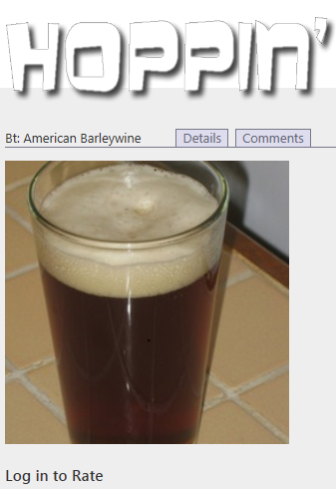

Prepared By:
Caleb Simmons, Michael Grenon, and James Glass
Date:
4/17/2013

CS 687: Database Systems Project 2(a)
Table of Contents
Table of Referenced Documents 3
Team Members and their Contributions 4
Concept and “Miniworld” Description 5
Project Plan 8
Database Design 8
Hop Details with Supporting Entities and Relationships 11
Fermentable Details with Supporting Entities and Relationships 12
Yeast Details with Supporting Entities and Relationships 13
Style Details with Supporting Entities and Relationships 14
MashProfile Details with Supporting Entities and Relationships 15
Recipe Details with Supporting Entities, Relationships 16
Tying it All Together: The Complete Schema 17
The Schema Relations with their Constraints 18
MVC ASP Model Class Definitions and their Create Table Statements 25
Additional Constraints for Database Tables 46
User Interface 51
Intro Page – Recipe List Page 51
User Login and Registration 52
Recipe Details Page 54
Create New Hop and Create New Fermentable Dialogs 57
Recipe Comments Page 58
Ingredients Pages 60
Create Recipe Page 62
Implementation Overview 64
Views: 65
ViewModels: 66
Controllers: 66
Models: 66
Utilities: 67
Misc: 67
Meeting Minutes 68

Table of Referenced Documents
Smith, Brad, Drew Avis, Michael Taylor, Andrew Perron, and David Johnson. "The BeerXML Beer Recipes Exchange Standard." BeerXML Recipe Standard. N.p., 9 Oct. 2004. Web. 14 Apr. 2013.
"Brewtarget Beer Software." Brewtarget. N.p., n.d. Web. 14 Apr. 2013.
Introduction
This report documents the efforts of the “Hoppin’ Brew Social” database application team in completion of the group project assignment for the Spring 2013 session of CS 687: Database Systems. There were two options available for completion: an application option (“Project 2(a)”) and a research option (“Project 2(b)”). The team chose to pursue the application option, and the result was the “Hoppin’ Brew Social” database application, which this document describes in detail.

Team Members and their Contributions
The team consisted of the following members, with their stated roles:
- Caleb Simmons (Team Lead, “Back-End” Development Lead)
- Michael Grenon (“Front-End” Development Lead)
- James Glass (Special Projects, Test Lead, Report Editor)
The group project requirements specifically stated that all team members should have specialized roles within the team, yet also contribute at all levels of design and development of the database application. A special effort was made by the team to ensure that this requirement was met. Thus, while Caleb Simmons as “Back-End” Development Lead headed the effort to translate the database design into code, all team members participated in coding create statements for database tables. Similarly, Michael Grenon was not the only contributor to the “Front-End” user interface code and queries, and neither was James Glass the only team member to contribute to the report or testing the application during development; all team members participated in each of these activities while still maintaining a focus on the responsibilities required of their specialized roles.
More specifically, the major contributions of each team member may be summarized as follows:
- Caleb Simmons led the team, and was responsible for moving the discussion forward during meetings as well as maintaining a record of the topics discussed at those meetings and action items arising from them. During the implementation phase, Caleb was largely responsible for the implementation of the database schema, as well as initial population of the database by parsing an XML-based external data source. Caleb also was responsible for the queries and user interface code required to support the user login and account management features.
- Michael Grenon led the development effort of the web-based user interface, as well as development of code and queries for its interactions with the underlying database. Michael also contributed to the implementation of the development schema, defining tables for use with the recipe rating system and similar features, many of which were also conceived by him.
- James Glass led the testing effort, as well as the generation of content for the project report and revisions of its draft versions. He also was assigned the task of implementing special projects for the development effort, including the development of algorithms for site-wide Bayesian averaging of user ratings for recipes, derivation of measurements of brew characteristics based on their chemical properties, and similar calculations as required by the team. His largest single contribution to the implementation of the application was in the conception, design, and implementation of the “Flavor Wheel” feature, including the user interface code, database tables, and queries needed to support it.
Additionally, each team member had a roughly equivalent degree of input to the conceptual and logical design of the database itself, and each team member was assigned sections of the report to contribute to the initial draft.

Concept and “Miniworld” Description
The “Hoppin’ Brew Social” application devised by the team is a centralized, homogenous, multi-user, read-write database system accessible through a web user interface. The issues arising from multi-user concurrency are handled through restrictions in the design of the database and in the business logic of its web interface. The database is populated by realistic data from both an external source and from sample data manually entered into the database by the team.
The application concept defines a social networking application for beer brewing enthusiasts, promoting the sharing and discussion of brewing recipes. Users are able to set up a username and password for their user account, and then log in to peruse the database’s many community-submitted brewing recipes. Users are able to create and edit their own recipes, which will then be publicly viewable. Users are also able to rate recipes according to their appreciation for them, and to leave comments about the flavor a particular brew produced. The application also display useful information about the recipes and their usage, as well as the hops, “fermentables,” yeasts, and mashes involved.
Informally, the database “miniworld” comprises the following details:
- Users set up user profiles to gain access to the database. The user profiles should retain an ID number uniquely identifying the user, as well as the user’s (“screen”) name.
- Each user profile has zero or more membership entries that track the date created, confirmation. The membership handles security information relating to the user’s password. Password information tracked includes; last password failure date, the count of password failures since last success, the hashed current password, the date the password was changed, the password cryptography salt, the password verification token and expiration date.
- Users may create, edit, and view brewing recipes. These recipes should describe the (extensive) brewing factors and instructions that must be used to recreate a particular brew, such as the specified batch size (the amount of fluid rendered from boiling), the boil size (the amount of fluid prior to boiling), the duration of the boil stage, the efficiency of the boiling process as a percentage, the original and final gravity, the durations of the primary, secondary, and tertiary (if needed) aging stages and their required temperatures, the duration of the bottle or keg aging stage and its required temperature, the volumes of carbon and forced carbonation, the keg priming factor, the allowable priming sugar equivalents, the fermentation stages for the recipe, and any other notes about the process or the resulting taste that might accompany the recipe. The recipe should be uniquely identifiable by name, with its date of creation included in the database record. An optional image representing the brew may be stored in the database for display. The recipe should be associated with both its type (“All-Grain,” “Extract”, etc.) and style (“American Pale Ale,” “Applewine,” etc.), as well as the particular mash it makes use of and the user or users who collaborated on its creation. Each recipe may be “owned” by one or more users, while each user may “own” zero or more recipes.
- Recipes can be categorized according to their style, and each of these styles has characteristics of its own which influence the recipe and are also recorded by the database. Each style is similarly uniquely identifiable by its name, and each style record retains information on the style’s category name and number, style letter and guide, the minimum and maximum original and final gravity of brews made in this style, but minimum and maximum bitterness of brews made in this style (measured in IBUs), the minimum and maximum CRAB, color, and alcohol by volume (ABV), as well as the style’s profile, ingredients, examples, and notes. Each style should be associated with its representative style type, which need only be identifiable by name (essentially an enumerated type).
- Recipes use yeasts, and the system must retain information describing these yeasts. Each yeast is uniquely recognizable by name, and users should be able to view the yeast’s recommended amount, the name of the laboratory that produced it, its product ID, its minimum and maximum recommended usage temperatures, its attenuation factor, and the number of times it has been cultured. In addition, each yeast should be associated with a yeast type, a yeast flocculation, and a yeast form, each of which need only be identifiable by name (enumerations).
- Recipes also use fermentables, which should be uniquely identified by name, and the application should be prepared to display information on the fermentable’s recommended amount, its yield, color, origin, supplier name, coarse/fine differential, moisture level, diastatic power, quantity of protein, and contribution to bitterness in IBUs. Each fermentable should be associated with a fermentable type, which need only be identifiable by name (an enumeration).
- Recipes also use hops, which should be uniquely identified by name, and the application should be prepared to display information on each hop’s alpha and beta, recommended amount and time, HSI, origin, notes any substitutes that may be used in its place, and its quantities of humulene, caryophyllene, cohumulone, and myrcene. Additionally, each hop should be associated with its type and form, which need only be identifiable their names.
- Finally, each recipe makes use of a single mash to complete the brewing process. The database should keep track of each mash profile separately, and have them identifiable by a unique number. Each such profile should contain information on the mash’s name, grain temperature, sparge temperature, tun temperature, tun weight and specific heat, the desired PH of the mash, and any notes about the mash or how to perform it. In addition to the mash’s profile, each step in the mash process should separately maintain its own uniquely identifying number, as well as its own name, infusion quantity and temperature, temperature and duration, ramp duration, ending target temperature, step sequence number, and decoction amount; the step should also be associated with a mash step type, which need only be identifiable by name, and the profile of the mash which “contains” it.
- A recipe may make use of one or more fermentables, and each fermentable may be used by zero or more recipes. Wherever a recipe and a fermentable are uniquely associated, we should be certain to make note of whether or not that fermentable is meant to be mashed, and also whether or not it is meant to be added after the boil stage of the recipe.
- A recipe may make use of one or more hops, and each hop may be used by zero or more recipes. Wherever a recipe and a hop are uniquely associated, we should be certain to make note of that hop’s use in the recipe, which need only be identifiable by name (the “name” of the use in the recipe, an enumerated type).
- A recipe may make use of one or more yeasts, and each yeast may be used by zero or more recipes. Wherever a recipe and a yeast are uniquely associated, we should be certain to make note of whether or not that yeast is considered a “secondary” yeast by the associated recipe.
- In addition to creating, editing, and viewing data about the previously mentioned entity types, users may also “rate” any recipe in the database according to appreciation for that recipe—one rating per user per recipe. This rating should be scored as a simple integer value between 1 and 10.
- Users may also post comments on the flavor of beer produced by each recipe. Each user may post as many comments as they like, each associated with a particular recipe and the user’s account profile, and with each comment additionally being distinguishable by the timestamp taken at its posting. The comment may optionally contain text, but must always reference one of a set of unique and predetermined “flavor profiles,” each of which need only be identified by name (another enumerated type). As each of these flavor profiles may be associated with a recipe zero or more times through user comments, the web user interface will also be able to display information on what overall “flavor profile” the user community has collectively decided a particular recipe will produce.

Project Plan
The team’s plan for completing the project is informally described below:
Phase 1: Concept Definition (Weeks 1 - 4)
Goals:
- Each team member will contribute ideas for project application concepts
- The team will debate the strengths and weakness of competing concepts
- The team will agree on a concept and generate an initial concept description
Phase 2: Design (Weeks 5 - 8)
Goals:
- Each team member will contribute ideas for realizing the conceptual and logical designs of the database
- The team will periodically review the current design and revise where needed
- The team will also consider desirable user interface features and how the design might support them
- The team will further define individual team member roles in anticipation of the implementation stage
Phase 3: Implementation, Integration, and Test (Weeks 9 - 14)
Goals:
- The DBMS and development environment will be selected (ASP MVC in MS Visual Studio C#)
- Each team member will complete the programming tutorial for the chosen development tools
- Each team member will implement application code according to his assigned role and responsibilities
- Each team member will also contribute code to each level of the application (user interface, database interaction code and queries, and database table definition and creation)
- Each team member will contribute to the generation of the report document
- The database design will be revised as further flaws are detected; erroneous entities and attributes will be removed or repurposed, while new entities and attributes will be added to accommodate concept and user interface features, as needed
- Rigorous testing of the feature to be demonstrated will be performed
- The draft report document will be revised until it accurately describes the project while conforming to the stated requirements for the project set by Dr. Aygun
Phase 4: Deployment and Demonstration (Week 15 - 16)
Goals:
- Each team member will contribute to the demonstration presentation
- The team will submit the final report and application code to Dr. Aygun
- The team will present their project and the application to the class

Database Design
This section describes the logical design of the database, including ER diagrams, their mappings into the database schema, table definitions with domain, attribute, and key constraints, and the ASP MVC model class definitions with the table create statements they were mapped into.
First is a partial ER diagram which seeks to illustrate the scope of the application database and the relationships between entities:
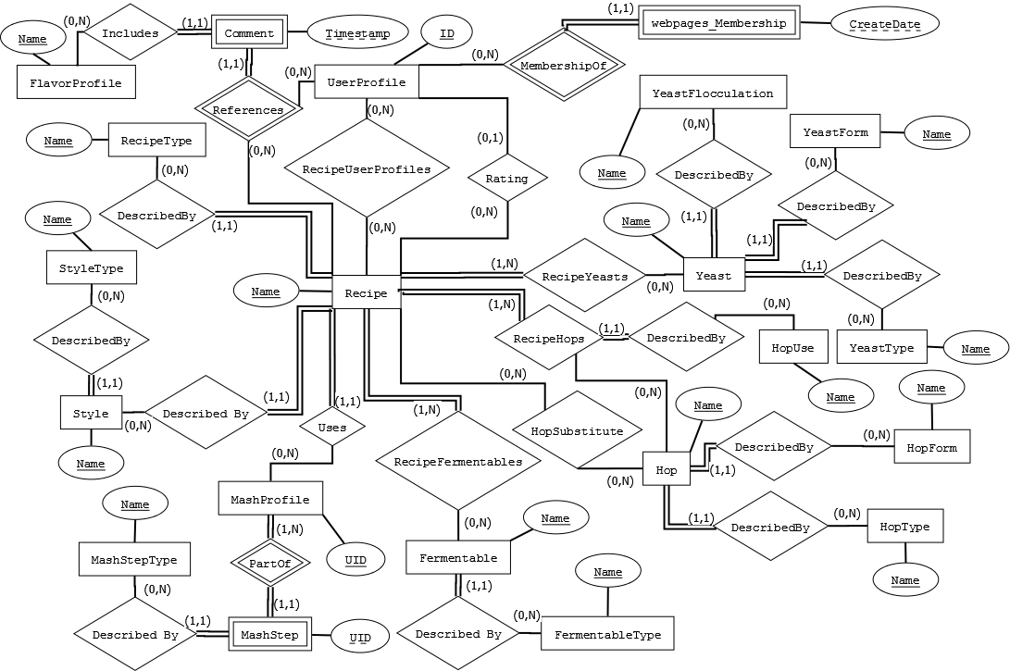
It should be noted here that this diagram ignores non-key entity attributes in order to somewhat simplify the diagram; it focuses instead on revealing the cardinalities and participation of the entities and their relationships across the entire database design. In the upcoming sections, logically grouped entities and relationships will be examined in more detail, with their attributes fully exploded and their mappings to the resulting database schema revealed.
UserProfile Details with Supporting Entities and Relationships
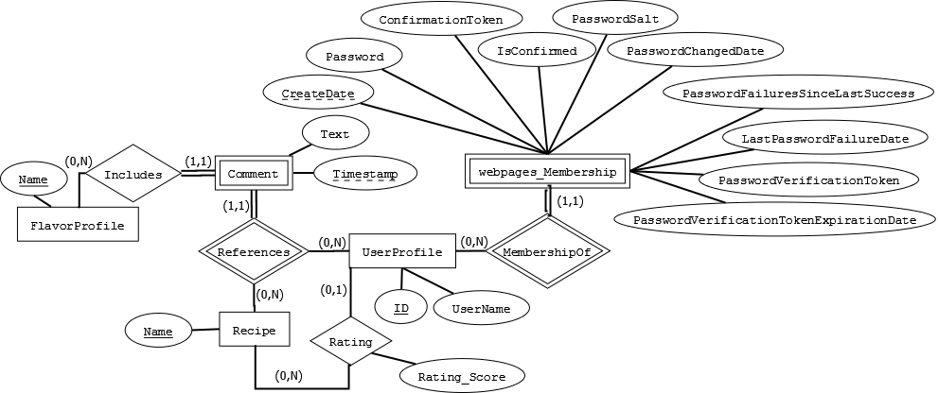
This diagram shows the details of entities and relationships which were mapped into the following partial schema definition:
FlavorProfile(Name)
UserProfile(ID, UserName)
Rating(Recipe_Name, UserProfile_UserID, Rating_Score)
Comment(Recipe_Name, UserProfile_UserID, Timestamp, Text, FlavorProfile_Name)
webpages_Membership(UserId, CreateDate, ConfirmationToken, IsConfirmed, LastPasswordFailureDate, PasswordFailuresSinceLastSuccess, Password, PasswordChangedDate, PasswordSalt, PasswordVerificationToken, PasswordVerificationTokenExpirationDate)
Hop Details with Supporting Entities and Relationships
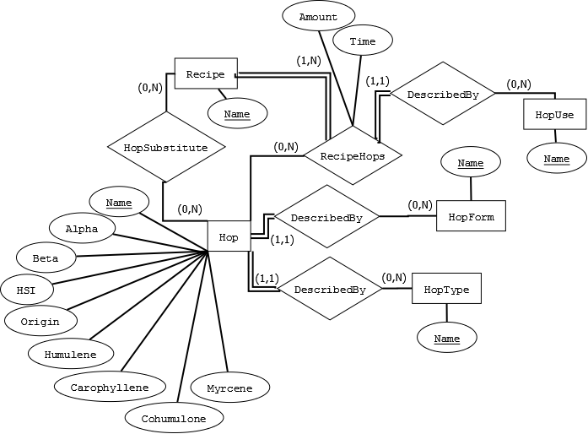
This diagram shows the details of entities and relationships which were mapped into the following partial schema definition:
HopUse(Name)
HopForm(Name)
HopType(Name)
RecipeHops(Recipe_Name, Hop_Name, HopUses_Name, Amount, Time)
HopSubstitute(Hop_Name, Recipe_Name)
Hop(Name, Alpha, Beta, HSI, Origin, Humulene, Caryophyllene, Cohumulone, Myrcene, HopForm_Name, HopType_Name)

Fermentable Details with Supporting Entities and Relationships
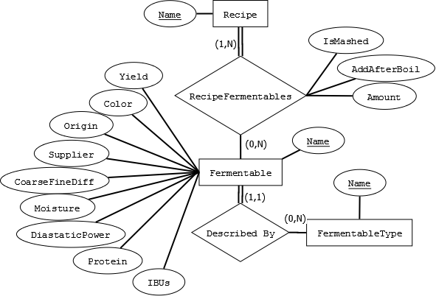
This diagram shows the details of entities and relationships which were mapped into the following partial schema definition:
FermentableType(Name)
RecipeFermentables(Recipe_Name, Fermentable_Name, IsMashed, AddAfterBoil, Amount)
Fermentable(Name, Yield, Color, Origin, Supplier, CoarseFineDiff, Moisture, DiastaticPower, Protein, IBUs, FermentableType_Name)

Yeast Details with Supporting Entities and Relationships
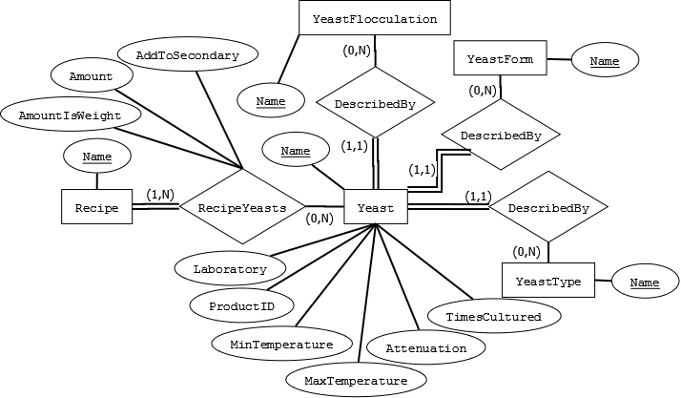
This diagram shows the details of entities and relationships which were mapped into the following partial schema definition:
YeastForm(Name)
YeastType(Name)
YeastFlocculation(Name)
RecipeYeasts(Recipe_Name, Yeast_Name, AddToSecondary, Amount, AmountIsWeight)
Yeast(Name, Laboratory, ProductID, MinTemperature, MaxTemperature, Attenuation, TimesCultured, YeastType_Name, YeastFlocculation_Name, YeastForm_Name)

Style Details with Supporting Entities and Relationships
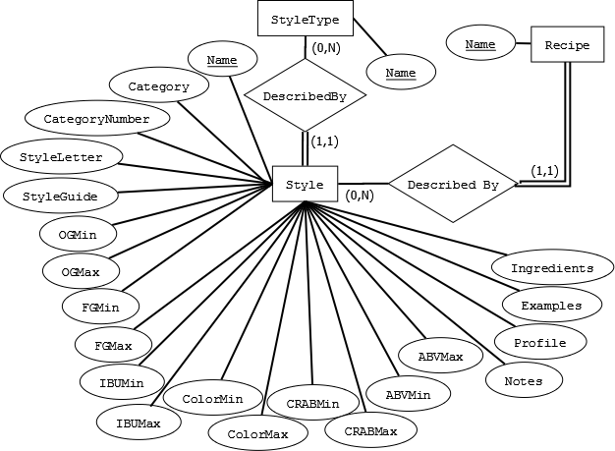
This diagram shows the details of entities and relationships which were mapped into the following partial schema definition:
StyleType(Name)
Style(Name, Category, CategoryNumber, StyleLetter, StyleGuide, OGMin, OGMax, FGMin, FGMax, IBUMin, IBUMax, ColorMin, ColorMax, CRABMin, CRABMax, ABVMin, ABVMax, Notes, Profile, Ingredients, Examples, StyleType_Name)

MashProfile Details with Supporting Entities and Relationships
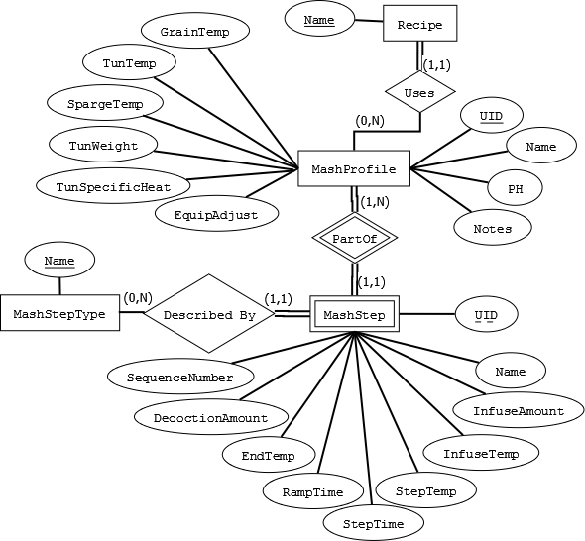
This diagram shows the details of entities and relationships which were mapped into the following partial schema definition:
MashStepType(Name)
MashStep(MashProfile_UID, UID, Name, InfuseAmount, StepTemp, StepTime, RampTime, EndTemp, InfuseTemp, DecoctionAmount, SequenceNumber, MashStepType_Name)
MashProfile(UID, Name, GrainTemp, Notes, TunTemp, SpargeTemp, PH, TunWeight, TunSpecificHeat, EquipAdjust)

Recipe Details with Supporting Entities, Relationships
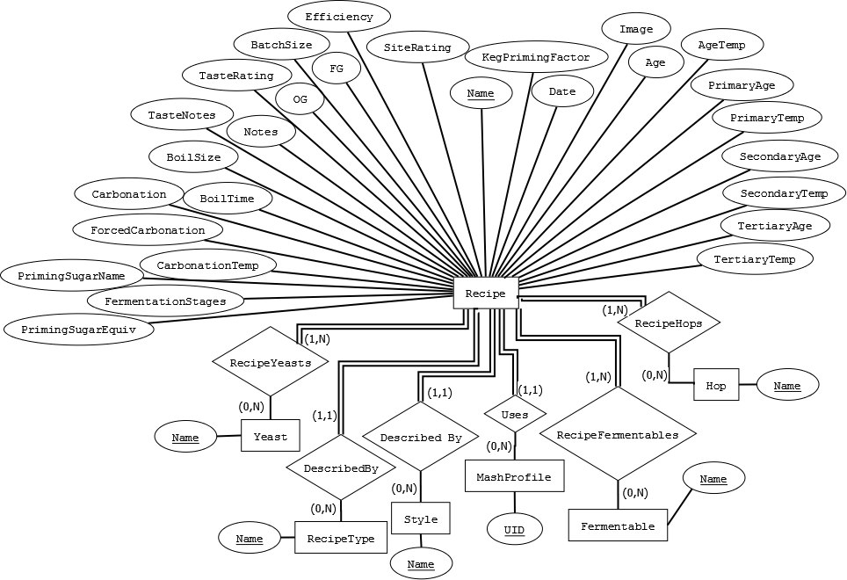
This diagram shows the details of entities and relationships which were mapped into the following partial schema definition:
RecipeType(Name)
Recipe(Name, BatchSize, BoilSize, BoilTime, Efficiency, Notes, TasteNotes, TasteRating, OG, FG, FermentationStages, PrimaryAge, PrimaryTemp, SeconaryAge, SecondaryTemp, TertiaryAge, TertiaryTemp, Age, AgeTemp, Date, Carbonation, ForcedCarbonation, PrimingSugarName, CarbonationTemp, PrimingSugarEquiv, KegPrimingFactor, SiteRating, Image, RecipeType_Name, Style_Name, Mash_UID)
Tying it All Together: The Complete Schema
FlavorProfile(Name)
UserProfile(ID, UserName)
RecipeUserProfiles(Recipe_Name, UserProfile_UserId)
Rating(Recipe_Name, UserProfile_UserID, Rating_Score)
Comment(Recipe_Name, UserProfile_UserID, Timestamp, Text, FlavorProfile_Name)
webpages_Membership(UserId, CreateDate, ConfirmationToken, IsConfirmed, LastPasswordFailureDate, PasswordFailuresSinceLastSuccess, Password, PasswordChangedDate, PasswordSalt, PasswordVerificationToken, PasswordVerificationTokenExpirationDate)
HopUse(Name)
HopForm(Name)
HopType(Name)
RecipeHops(Recipe_Name, Hop_Name, HopUses_Name, Amount, Time)
HopSubstitute(Hop_Name, Recipe_Name)
Hop(Name, Alpha, Beta, HSI, Origin, Humulene, Caryophyllene, Cohumulone, Myrcene, HopForm_Name, HopType_Name)
FermentableType(Name)
RecipeFermentables(Recipe_Name, Fermentable_Name, IsMashed, AddAfterBoil, Amount)
Fermentable(Name, Yield, Color, Origin, Supplier, CoarseFineDiff, Moisture, DiastaticPower, Protein, IBUs, FermentableType_Name)
YeastForm(Name)
YeastType(Name)
YeastFlocculation(Name)
RecipeYeasts(Recipe_Name, Yeast_Name, AddToSecondary, Amount, AmountIsWeight)
Yeast(Name, Laboratory, ProductID, MinTemperature, MaxTemperature, Attenuation, TimesCultured, YeastType_Name, YeastFlocculation_Name, YeastForm_Name)
StyleType(Name)
Style(Name, Category, CategoryNumber, StyleLetter, StyleGuide, OGMin, OGMax, FGMin, FGMax, IBUMin, IBUMax, ColorMin, ColorMax, CRABMin, CRABMax, ABVMin, ABVMax, Notes, Profile, Ingredients, Examples, StyleType_Name)
MashStepType(Name)
MashStep(MashProfile_UID, UID, Name, InfuseAmount, StepTemp, StepTime, RampTime, EndTemp, InfuseTemp, DecoctionAmount, SequenceNumber, MashStepType_Name)
MashProfile(UID, Name, GrainTemp, Notes, TunTemp, SpargeTemp, PH, TunWeight, TunSpecificHeat, EquipAdjust)
RecipeType(Name)
Recipe(Name, BatchSize, BoilSize, BoilTime, Efficiency, Notes, TasteNotes, TasteRating, OG, FG, FermentationStages, PrimaryAge, PrimaryTemp, SeconaryAge, SecondaryTemp, TertiaryAge, TertiaryTemp, Age, AgeTemp, Date, Carbonation, ForcedCarbonation, PrimingSugarName, CarbonationTemp, PrimingSugarEquiv, KegPrimingFactor, SiteRating, Image, RecipeType_Name, Style_Name, Mash_UID)
The Schema Relations with their Constraints
Relation: FlavorProfile | Name
Domain Constraints: | nvarchar[50]
Attribute Constraints: | None
Primary Key? | Yes
Foreign Key? | No

Relation: UserProfile | ID | UserName
Domain Constraints: | int
Attribute Constraints: | None
Primary Key? | Yes | No
Foreign Key? | No | Yes, to UserProfile.ID

Relation: RecipeUserProfiles | Recipe_Name | UserProfile_UserId
Domain Constraints: | nvarchar[75] | int
Attribute Constraints: | None | None
Primary Key? | Yes | Yes
Foreign Key? | Yes, to Recipe.Name | Yes, to UserProfile.ID

Relation: Rating | Recipe_Name | UserProfile_UserID | Rating_Score
Domain Constraints: | nvarchar[75] | int | int
Attribute Constraints: | None | None | 1 <= value <= 10
Primary Key? | Yes | Yes | No
Foreign Key? | Yes, to Recipe.Name | Yes, to UserProfile.ID | No

Relation: Comment | Recipe_Name | UserProfile_UserID | Timestamp | Text | FlavorProfile_Name
Domain Constraints: | nvarchar[75] | int | datetime | nvarchar[250] | nvarchar[50]
Attribute Constraints: | None | None | None | None | None
Primary Key? | Yes | Yes | Yes | No | No
Foreign Key? | Yes, to Recipe.Name | Yes, to UserProfile.ID | No | No | Yes, to FlavorProfile.Name

Relation: webpages_Membership | UserId | CreateDate | ConfirmationToken | IsConfirmed
Domain Constraints: | int | datetime | nvarchar[128] | bit
Attribute Constraints: | None | None | None | None
Primary Key? | Yes | Yes | No | No
Foreign Key? | Yes, to UserProfile.ID | No | No | No
 | LastPasswordFailureDate | PasswordFailuresSinceLastSucces | Password | PasswordChangedDate
Domain Constraints: | datetime | int | nvarchar[128] | datetime
Attribute Constraints: | None | None | None | None
Primary Key? | No | No | No | No
Foreign Key? | No | No | No | No
 | PasswordSalt | PasswordVerificationToken | PasswordVerificationTokenExpirationDate
Domain Constraints: | nvarchar[128] | nvarchar[128] | nvarchar[128] | datetime
Attribute Constraints: | None | None | None | None
Primary Key? | No | No | No | No
Foreign Key? | No | No | No | No

Relation: HopUse | Name
Domain Constraints: | nvarchar[75]
Attribute Constraints: | None
Primary Key? | Yes
Foreign Key? | No

Relation: HopForm | Name
Domain Constraints: | nvarchar[75]
Attribute Constraints: | None
Primary Key? | Yes
Foreign Key? | No

Relation: HopType | Name
Domain Constraints: | nvarchar[75]
Attribute Constraints: | None
Primary Key? | Yes
Foreign Key? | No

Relation: RecipeHops | Recipe_Name | Hop_Name | HopUses_Name | Amount | Time
Domain Constraints: | nvarchar[75] | nvarchar[75] | nvarchar[75] | real | real
Attribute Constraints: | None | None | None | None | None
Primary Key? | Yes | Yes | No | No | No
Foreign Key? | Yes, to Recipe.Name | Yes, to Hop.Name | Yes, to HopUes.Name | No | No

Relation: HopsSubstitute | Hop_Name | Recipe_Name
Domain Constraints: | nvarchar[75] | nvarchar[75]
Attribute Constraints: | None | None
Primary Key? | Yes | Yes
Foreign Key? | Yes, to Hop.Name | Yes, to Recipe.Name

Relation: Hop | Name | Alpha | Beta | HSI | Origin
Domain Constraints: | nvarchar[75] | real | real | real | nvarchar[75]
Attribute Constraints: | None | 0 <=Value <= 100 | 0 <=Value <= 100 | 0 <=Value <= 100 | None
Primary Key? | Yes | No | No | No | No
Foreign Key? | No | No | No | No | No
 | Humulene | Caryophyllene | Cohumulone | Myrcene | HopForm_Name | HopType_Name
Domain Constraints: | real | real | real | real | nvarchar[75] | nvarchar[75]
Attribute Constraints: | 0 <=Value <= 100 | 0 <=Value <= 100 | 0 <=Value <= 100 | 0 <=Value <= 100 | None | None
Primary Key? | No | No | No | No | No | No
Foreign Key? | No | No | No | No | Yes, to HopForm.Name | Yes, to HopType.Name

Relation: FermentableType | Name
Domain Constraints: | nvarchar[75]
Attribute Constraints: | None
Primary Key? | Yes
Foreign Key? | No

Relation: RecipeFermentables | Recipe_Name | Fermentable_Name | IsMashed | AddAfterBoil | Amount
Domain Constraints: | nvarchar[75] | nvarchar[75] | bit | bit | real
Attribute Constraints: | None | None | None | None | None
Primary Key? | Yes | Yes | No | No | No
Foreign Key? | Yes, to Recipe.Name | Yes, to Fermentable.Name | No | No | No

Relation: Fermentable | Name | Yield | Color | Origin | Supplier
Domain Constraints: | nvarchar[75] | real | real | nvarchar[75] | nvarchar[75]
Attribute Constraints: | None | 0 <=Value <= 100 | None | None | None
Primary Key? | Yes | No | No | No | No
Foreign Key? | No | No | No | No | No
 | CoarseFineDiff | Moisture | DiastaticPower | Protein | IBUs | FermentableType_Name
Domain Constraints: | real | real | real | real | real | nvarchar[75]
Attribute Constraints: | None | 0 <=Value <= 100 | 0 <=Value | 0 <=Value <= 100 | 0 <=Value | None
Primary Key? | No | No | No | No | No | No
Foreign Key? | No | No | No | No | No | Yes, to FermentableType.Name

Relation: YeastForm | Name
Domain Constraints: | nvarchar[75]
Attribute Constraints: | None
Primary Key? | Yes
Foreign Key? | No

Relation: YeastType | Name
Domain Constraints: | nvarchar[75]
Attribute Constraints: | None
Primary Key? | Yes
Foreign Key? | No

Relation: YeastFlocculation | Name
Domain Constraints: | nvarchar[75]
Attribute Constraints: | None
Primary Key? | Yes
Foreign Key? | No

Relation: RecipeYeasts | Recipe_Name | Yeast_Name | AddToSecondary | Amount | AmountIsWeight
Domain Constraints: | nvarchar[75] | nvarchar[75] | bit | real | bit
Attribute Constraints: | None | None | None | None | None
Primary Key? | Yes | Yes | No | No | No
Foreign Key? | Yes, to Recipe.Name | Yes, to Yeast.Name | No | No | No

Relation: Yeast | Name | Laboratory | ProductID | MinTemperature | MaxTemperature
Domain Constraints: | nvarchar[75] | nvarchar[75] | int | real | real
Attribute Constraints: | None | None | None | >=-50, <=110 | >=-50, <=110
Primary Key? | Yes | No | No | No | No
Foreign Key? | No | No | No | No | No
 | Attenuation | TimesCultured | YeastType_Name | YeastFlocculation_Name | YeastForm_Name
Domain Constraints: | real | int | nvarchar[75] | nvarchar[75] | nvarchar[75]
Attribute Constraints: | >=-50, <=110 | >=0, <=150 | None | None | None
Primary Key? | No | No | No | No | No
Foreign Key? | No | No | Yes, to YeastType.Name | Yes, to YeastFlocculation.Name | Yes, to YeastForm.Name

Relation: StyleType | Name
Domain Constraints: | nvarchar[75]
Attribute Constraints: | None
Primary Key? | Yes
Foreign Key? | No

Relation: MashStepType | Name
Domain Constraints: | nvarchar[75]
Attribute Constraints: | None
Primary Key? | Yes
Foreign Key? | No

Relation: Style | Name | Category | CategoryNumber | StyleLetter | StyleGuide
Domain Constraints: | nvarchar[75] | nvarchar[75] | nvarchar[-1] | nvarchar[1] | nvarchar[-1]
Attribute Constraints: | None | None | None | None | None
Primary Key? | Yes | No | No | No | No
Foreign Key? | No | No | No | No | No
 | OGMin | OGMax | FGMin | FGMax | IBUMin | IBUMax
Domain Constraints: | real | real | real | real | real | real
Attribute Constraints: | None | None | None | None | None | None
Primary Key? | No | No | No | No | No | No
Foreign Key? | No | No | No | No | No | No

 | ColorMin | ColorMax | CRABMin | CRABMax | ABVMin | ABVMax
Domain Constraints: | real | real | real | real | real | real
Attribute Constraints: | None | None | None | None | None | None
Primary Key? | No | No | No | No | No | No
Foreign Key? | No | No | No | No | No | No
 | Notes | Profile | Ingredients | Examples | StyleType_Name
Domain Constraints: | nvarchar[-1] | nvarchar[-1] | nvarchar[-1] | nvarchar[-1] | nvarchar[75]
Attribute Constraints: | None | None | None | None | None
Primary Key? | No | No | No | No | No
Foreign Key? | No | No | No | No | Yes, to StyleType.Name

Relation: MashProfile | UID | Name | GrainTemp | Notes | TunTemp
Domain Constraints: | int | nvarchar[75] | real | nvarchar[-1] | >=-50, <=110
Attribute Constraints: | None | None | >=-50, <=110 | None | None
Primary Key? | Yes | No | No | No | No
Foreign Key? | No | No | No | No | No
 | SpargeTemp | PH | TunWeight | TunSpecificHeat | EquipAdjust
Domain Constraints: | real | real | real | real | bit
Attribute Constraints: | >=-50, <=110 | >=-1, <=11.5 | >=0 | >=0 | None
Primary Key? | No | No | No | No | No
Foreign Key? | No | No | No | No | No

Relation: MashStep | MashProfile_UID | UID | Name | InfuseAmount | StepTemp | StepTime
Domain Constraints: | int | int | nvarchar[75] | real | real | real
Attribute Constraints: | None | None | None | None | >=-50, <=110 | >=0, <=1140
Primary Key? | Yes | Yes | No | No | No | No
Foreign Key? | Yes, to MashProfile.UID | No | No | No | No | No
 | RampTime | EndTemp | InfuseTemp | DecoctionAmount | SequenceNumber | MashStepType_Name
Domain Constraints: | real | real | real | real | int | nvarchar[75]
Attribute Constraints: | >=0, <=1140 | >=-50, <=110 | >=-50, <=110 | >=0, <=1000 | >=1, <=1000 | None
Primary Key? | No | No | No | No | No | No
Foreign Key? | No | No | No | No | No | Yes, to MashStepType.Name

Relation: RecipeType | Name
Domain Constraints: | nvarchar[75]
Attribute Constraints: | None
Primary Key? | Yes
Foreign Key? | No

Relation: Recipe | Name | BatchSize | BoilSize | BoilTime | Efficiency | Notes
Domain Constraints: | nvarchar[75] | real | real | real | real | nvarchar[-1]
Attribute Constraints: | None | None | None | None | None | None
Primary Key? | Yes | No | No | No | No | No
Foreign Key? | No | No | No | No | No | No
 | TasteNotes | TasteRating | OG | FG | FermentationStages | PrimaryAge
Domain Constraints: | nvarchar[-1] | real | real | real | int | real
Attribute Constraints: | None | None | None | None | None | None
Primary Key? | No | No | No | No | No | No
Foreign Key? | No | No | No | No | No | No
 | PrimaryTemp | SecondaryAge | SecondaryTemp | TertiaryAge | TertiaryTemp | Age
Domain Constraints: | real | real | real | real | real | real
Attribute Constraints: | >=-50, <=110 | None | >=-50, <=110 | None | >=-50, <=110 | None
Primary Key? | No | No | No | No | No | No
Foreign Key? | No | No | No | No | No | No
 | AgeTemp | Date | Carbonation | ForceCarbonation | PrimingSugarName | CarbonationTemp
Domain Constraints: | real | datetime | real | bit | nvarchar[75] | bit
Attribute Constraints: | >=-50, <=110 | None | None | None | None | >=-50, <=110
Primary Key? | No | No | No | No | No | No
Foreign Key? | No | No | No | No | No | No
 | PrimingSugarEquiv | KegPrimingFactor | SiteRating | Image | RecipeType_Name | Style_Name | Mash_UID
Domain Constraints: | nvarchar[75] | real | real | real | real | varbinary[-1] | int
Attribute Constraints: | None | None | None | None | None | None | None
Primary Key? | No | No | No | No | No | No | No
Foreign Key? | No | No | No | No | Yes, to RecipeType.Name | Yes, to Style.Name | Yes, to Mash.UID
MVC ASP Model Class Definitions and their Create Table Statements
In ASP MVC with Microsoft Visual Studio’s Entity Framework (EF), database tables are created by first defining the “model” classes which will represent them in the server code, and then performing a “code-first migration” to generate create table and alter table statements for the underlying SQL database (although as the EF technology is still immature, these statements must often be edited for correctness by the programmer). This section provides both the model class definitions and their corresponding MVC SQL table create statements (in their final, corrected form) for each of the relations in the implemented application database.
FlavorProfile
[Table("FlavorProfile")]
public class FlavorProfile
{
[Key, StringLength(50)]
public string Name { get; set; }
}
CREATE TABLE [dbo].[FlavorProfile] (
[Name] NVARCHAR (50) NOT NULL,
CONSTRAINT [PK_dbo.FlavorProfile] PRIMARY KEY CLUSTERED ([Name] ASC)
);

UserProfile
[Table("UserProfile")]
public class UserProfile
{
[Key]
[DatabaseGeneratedAttribute(DatabaseGeneratedOption.Identity)]
public int UserId { get; set; }
public string UserName { get; set; }
public virtual ICollection<Recipe> Recipes { get; set; }

public UserProfile()
{
Recipes = new HashSet<Recipe>();
}
}
CREATE TABLE [dbo].[UserProfile] (
[UserId] INT IDENTITY (1, 1) NOT NULL,
[UserName] NVARCHAR (MAX) NULL,
PRIMARY KEY CLUSTERED ([UserId] ASC)
);

RecipeUserProfiles
CREATE TABLE [dbo].[RecipeUserProfiles] (
[Recipe_Name] NVARCHAR (75) NOT NULL,
[UserProfile_UserId] INT NOT NULL,
CONSTRAINT [PK_dbo.RecipeUserProfiles] PRIMARY KEY CLUSTERED ([Recipe_Name] ASC,
[UserProfile_UserId] ASC),
CONSTRAINT [FK_dbo.RecipeUserProfiles_dbo.Recipe_Recipe_Name] FOREIGN KEY
([Recipe_Name]) REFERENCES [dbo].[Recipe] ([Name]) ON DELETE CASCADE,
CONSTRAINT [FK_dbo.RecipeUserProfiles_dbo.UserProfile_UserProfile_UserId] FOREIGN
KEY ([UserProfile_UserId]) REFERENCES [dbo].[UserProfile]
([UserId]) ON DELETE CASCADE
);

GO
CREATE NONCLUSTERED INDEX [IX_Recipe_Name]
ON [dbo].[RecipeUserProfiles]([Recipe_Name] ASC);

GO
CREATE NONCLUSTERED INDEX [IX_UserProfile_UserId]
ON [dbo].[RecipeUserProfiles]([UserProfile_UserId] ASC);

Rating
[Table("Rating")]
public class Rating
{
[Key, Column(Order = 0), ForeignKey("Recipe")]
public string Recipe_Name { get; set; }
[Key, Column(Order = 1), ForeignKey("UserProfile")]
public int UserProfile_UserID { get; set; }

public UserProfile UserProfile { get; set; }
public Recipe Recipe { get; set; }

[Required, Range(0, 10)]
public int Rating_Score { get; set; }
}
CREATE TABLE [dbo].[Rating] (
[Recipe_Name] NVARCHAR (75) NOT NULL,
[UserProfile_UserID] INT NOT NULL,
[Rating_Score] INT NOT NULL,
CONSTRAINT [PK_dbo.Rating] PRIMARY KEY CLUSTERED ([Recipe_Name] ASC,
[UserProfile_UserID] ASC),
CONSTRAINT [FK_dbo.Rating_dbo.UserProfile_UserProfile_UserID] FOREIGN KEY
([UserProfile_UserID]) REFERENCES [dbo].[UserProfile]
([UserId]) ON DELETE CASCADE,
CONSTRAINT [FK_dbo.Rating_dbo.Recipe_Recipe_Name] FOREIGN KEY ([Recipe_Name])
REFERENCES [dbo].[Recipe] ([Name]) ON DELETE CASCADE
);

GO
CREATE NONCLUSTERED INDEX [IX_UserProfile_UserID]
ON [dbo].[Rating]([UserProfile_UserID] ASC);

GO
CREATE NONCLUSTERED INDEX [IX_Recipe_Name]
ON [dbo].[Rating]([Recipe_Name] ASC);

Comment
[Table("Comment")]
public class Comment
{
[Key, Column(Order = 0), ForeignKey("Recipe")]
public string Recipe_Name { get; set; }
[Key, Column(Order = 1), ForeignKey("UserProfile")]
public int UserProfile_UserID { get; set; }

public UserProfile UserProfile { get; set; }
public Recipe Recipe { get; set; }

[Key, Column(Order = 2)]
public System.DateTime Timestamp { get; set; }
public FlavorProfile FlavorProfile { get; set; }

[Required, StringLength(50), ForeignKey("FlavorProfile")]
public string FlavorProfile_Name { get; set; }

[StringLength(250)]
public string Text { get; set; }
}
CREATE TABLE [dbo].[Comment] (
[Timestamp] DATETIME NOT NULL,
[Text] NVARCHAR (250) NULL,
[UserProfile_UserId] INT NOT NULL,
[Recipe_Name] NVARCHAR (75) NOT NULL,
[FlavorProfile_Name] NVARCHAR (50) NOT NULL,
CONSTRAINT [PK_dbo.Comment] PRIMARY KEY CLUSTERED ([Recipe_Name] ASC,
[UserProfile_UserId] ASC, [Timestamp] ASC),
CONSTRAINT [FK_dbo.Comment_dbo.UserProfile_UserProfile_UserID] FOREIGN KEY
([UserProfile_UserId]) REFERENCES [dbo].[UserProfile]
([UserId]) ON DELETE CASCADE,
CONSTRAINT [FK_dbo.Comment_dbo.Recipe_Recipe_Name] FOREIGN KEY ([Recipe_Name])
REFERENCES [dbo].[Recipe] ([Name]) ON DELETE CASCADE,
CONSTRAINT [FK_dbo.Comment_dbo.FlavorProfile_FlavorProfile_Name] FOREIGN KEY
([FlavorProfile_Name]) REFERENCES [dbo].[FlavorProfile]
([Name]) ON DELETE CASCADE
);

GO
CREATE NONCLUSTERED INDEX [IX_UserProfile_UserID]
ON [dbo].[Comment]([UserProfile_UserId] ASC);

GO
CREATE NONCLUSTERED INDEX [IX_FlavorProfile_Name]
ON [dbo].[Comment]([FlavorProfile_Name] ASC);

GO
CREATE NONCLUSTERED INDEX [IX_Recipe_Name]
ON [dbo].[Comment]([Recipe_Name] ASC);

webpages_Membership
CREATE TABLE [dbo].[webpages_Membership] (
[UserId] INT NOT NULL,
[CreateDate] DATETIME NULL,
[ConfirmationToken] NVARCHAR (128) NULL,
[IsConfirmed] BIT DEFAULT ((0)) NULL,
[LastPasswordFailureDate] DATETIME NULL,
[PasswordFailuresSinceLastSuccess] INT DEFAULT ((0)) NOT NULL,
[Password] NVARCHAR (128) NOT NULL,
[PasswordChangedDate] DATETIME NULL,
[PasswordSalt] NVARCHAR (128) NOT NULL,
[PasswordVerificationToken] NVARCHAR (128) NULL,
[PasswordVerificationTokenExpirationDate] DATETIME NULL,
PRIMARY KEY CLUSTERED ([UserId] ASC)
);

HopUse
[Table("HopUse")]
public class HopUse
{
[Key, StringLength(75)]
public string Name { get; set; }
}
CREATE TABLE [dbo].[HopUse] (
[Name] NVARCHAR (75) NOT NULL,
CONSTRAINT [PK_dbo.HopUse] PRIMARY KEY CLUSTERED ([Name] ASC)
);

HopForm
[Table("HopForm")]
public class HopForm
{
[Key, StringLength(75)]
public string Name { get; set; }
}
CREATE TABLE [dbo].[HopForm] (
[Name] NVARCHAR (75) NOT NULL,
CONSTRAINT [PK_dbo.HopForm] PRIMARY KEY CLUSTERED ([Name] ASC)
);

HopType
[Table("HopType")]
public class HopType
{
[Key, StringLength(75)]
public string Name { get; set; }
}
CREATE TABLE [dbo].[HopType] (
[Name] NVARCHAR (75) NOT NULL,
CONSTRAINT [PK_dbo.HopType] PRIMARY KEY CLUSTERED ([Name] ASC)
);

RecipeHops
[Table("RecipeHops")]
public class RecipeHop : IEquatable<RecipeHop>
{
[Key, Column(Order = 0), ForeignKey("Recipe")]
public string Recipe_Name { get; set; }
[Key, Column(Order = 1), ForeignKey("Hop")]
public string Hop_Name { get; set; }

[ForeignKey("HopUse")]
public string HopUses_Name { get; set; }

public HopUse HopUse { get; set; }
public virtual Hop Hop { get; set; }
public virtual Recipe Recipe { get; set; }

[Required]
public float Amount { get; set; } // Weight in Kilograms of hops used in recipe.
[Required]
public float Time { get; set; } // Meaning is dependent on the “USE”

public override bool Equals(object obj)
{
return Equals(obj as RecipeHop);
}

public bool Equals(RecipeHop other)
{
return (other.Recipe_Name == this.Recipe_Name) &&
(other.Hop_Name == this.Hop_Name) /*&&
(other.HopUses_Name == this.HopUses_Name)*/;
}

public override int GetHashCode()
{
return this.Recipe_Name.GetHashCode() +
this.Hop_Name.GetHashCode()
/*+ HopUses_Name.GetHashCode()*/;
}
}
CREATE TABLE [dbo].[RecipeHops] (
[Recipe_Name] NVARCHAR (75) NOT NULL,
[Hop_Name] NVARCHAR (75) NOT NULL,
[HopUses_Name] NVARCHAR (75) NULL,
[Amount] REAL DEFAULT ((0)) NOT NULL,
[Time] REAL DEFAULT ((0)) NOT NULL,
CONSTRAINT [PK_dbo.RecipeHops] PRIMARY KEY
CLUSTERED ([Recipe_Name] ASC, [Hop_Name] ASC),
CONSTRAINT [FK_dbo.RecipeHops_dbo.Hop_Hop_Name]
FOREIGN KEY ([Hop_Name]) REFERENCES [dbo].[Hop] ([Name]) ON DELETE CASCADE,
CONSTRAINT [FK_dbo.RecipeHops_dbo.Recipe_Recipe_Name]
FOREIGN KEY ([Recipe_Name]) REFERENCES [dbo].[Recipe]
([Name]) ON DELETE CASCADE,
CONSTRAINT [FK_dbo.RecipeHops_dbo.HopUse_HopUses_Name] FOREIGN KEY
([HopUses_Name]) REFERENCES [dbo].[HopUse] ([Name])
);

GO
CREATE NONCLUSTERED INDEX [IX_Hop_Name]
ON [dbo].[RecipeHops]([Hop_Name] ASC);

GO
CREATE NONCLUSTERED INDEX [IX_Recipe_Name]
ON [dbo].[RecipeHops]([Recipe_Name] ASC);

GO
CREATE NONCLUSTERED INDEX [IX_HopUses_Name]
ON [dbo].[RecipeHops]([HopUses_Name] ASC);

HopSubstitute
[Table("HopSubstitute")]
public class HopSubstitute
{
[Key, Column(Order = 0), ForeignKey("Hop")]
public string Hop_Name { get; set; }
[Key, Column(Order = 1), ForeignKey("Recipe")]
public string Recipe_Name { get; set; }

public virtual Hop Hop { get; set; }
public virtual Recipe Recipe { get; set; }
}
CREATE TABLE [dbo].[HopSubstitute] (
[Hop_Name] NVARCHAR (75) NOT NULL,
[Recipe_Name] NVARCHAR (75) NOT NULL,
CONSTRAINT [PK_dbo.HopSubstitute] PRIMARY KEY CLUSTERED ([Hop_Name] ASC,
[Recipe_Name] ASC),
CONSTRAINT [FK_dbo.HopSubstitute_dbo.Hop_Hop_Name] FOREIGN KEY ([Hop_Name])
REFERENCES [dbo].[Hop] ([Name]) ON DELETE CASCADE,
CONSTRAINT [FK_dbo.HopSubstitute_dbo.Recipe_Recipe_Name] FOREIGN KEY
([Recipe_Name]) REFERENCES [dbo].[Recipe] ([Name]) ON DELETE CASCADE
);

GO
CREATE NONCLUSTERED INDEX [IX_Hop_Name]
ON [dbo].[HopSubstitute]([Hop_Name] ASC);

GO
CREATE NONCLUSTERED INDEX [IX_Recipe_Name]
ON [dbo].[HopSubstitute]([Recipe_Name] ASC);

Hop
[Table("Hop")]
public class Hop : IEquatable<Hop>
{
[Key, StringLength(75)]
public string Name { get; set; }
[Required, Range(0.0, 100)]
public float Alpha { get; set; } // Percent alpha of hops - for example
// "5.5" represents 5.5% alpha
public HopType HopType { get; set; }
public HopForm HopForm { get; set; }
[Range(0.0, 100)]
public float Beta { get; set; } // Hop beta %-for example "4.4" denotes 4.4% beta
[Range(0.0, 100)]
public float HSI { get; set; } // Hop Stability Index - defined as the percentage
// of hop alpha lost in 6 months of storage
[StringLength(75)]
public string Origin { get; set; } // Place of origin for the hops
[Range(0.0, 100)]
public float Humulene { get; set; } // Humulene level in percent
[Range(0.0, 100)]
public float Caryophyllene { get; set; } // Caryophyllene level in percent
[Range(0.0, 100)]
public float Cohumulone { get; set; } // Cohumulone level in percent
[Range(0.0, 100)]
public float Myrcene { get; set; } // Myrcene level in percent

[ForeignKey("HopForm")]
public string HopForm_Name { get; set; }

[ForeignKey("HopType")]
public string HopType_Name { get; set; }

public virtual ICollection<RecipeHop> RecipeHops { get; set; }

public virtual ICollection<HopSubstitute> Substitutes { get; set; }

public Hop()
{
RecipeHops = new HashSet<RecipeHop>();
Substitutes = new HashSet<HopSubstitute>();
}

public override bool Equals(object obj)
{
return Equals(obj as Hop);
}

public bool Equals(Hop other)
{
return (other.Name == this.Name);
}

public override int GetHashCode()
{
return this.Name.GetHashCode();
}
}
CREATE TABLE [dbo].[Hop] (
[Name] NVARCHAR (75) NOT NULL,
[Alpha] REAL NOT NULL,
[Beta] REAL NOT NULL,
[HSI] REAL NOT NULL,
[Origin] NVARCHAR (75) NULL,
[Humulene] REAL NOT NULL,
[Caryophyllene] REAL NOT NULL,
[Cohumulone] REAL NOT NULL,
[Myrcene] REAL NOT NULL,
[HopForm_Name] NVARCHAR (75) NULL,
[HopType_Name] NVARCHAR (75) NULL,
CONSTRAINT [PK_dbo.Hop] PRIMARY KEY CLUSTERED ([Name] ASC),
CONSTRAINT [FK_dbo.Hop_dbo.HopType_HopType_Name] FOREIGN KEY ([HopType_Name])
REFERENCES [dbo].[HopType] ([Name]),
CONSTRAINT [FK_dbo.Hop_dbo.HopForm_HopForm_Name] FOREIGN KEY ([HopForm_Name])
REFERENCES [dbo].[HopForm] ([Name])
);

GO
CREATE NONCLUSTERED INDEX [IX_HopType_Name]
ON [dbo].[Hop]([HopType_Name] ASC);

GO
CREATE NONCLUSTERED INDEX [IX_HopForm_Name]
ON [dbo].[Hop]([HopForm_Name] ASC);

FermentableType
[Table("FermentableType")]
public class FermentableType
{
[Key, StringLength(75)]
public string Name { get; set; }
}
CREATE TABLE [dbo].[FermentableType] (
[Name] NVARCHAR (75) NOT NULL,
CONSTRAINT [PK_dbo.FermentableType] PRIMARY KEY CLUSTERED ([Name] ASC)
);

RecipeFermentables
[Table("RecipeFermentables")]
public class RecipeFermentable : IEquatable<RecipeFermentable>
{
[Key, Column(Order = 0), ForeignKey("Recipe")]
public string Recipe_Name { get; set; }
[Key, Column(Order = 1), ForeignKey("Fermentable")]
public string Fermentable_Name { get; set; }

[Required]
public float Amount { get; set; } // Weight of the fermentable, extract or sugar
// in Kilograms.
public bool IsMashed { get; set; }
public bool AddAfterBoil { get; set; } // May be TRUE if this item is normally
// added after the boil.

public virtual Fermentable Fermentable { get; set; }
public virtual Recipe Recipe { get; set; }

public override bool Equals(object obj)
{
return Equals(obj as RecipeFermentable);
}

public bool Equals(RecipeFermentable other)
{
return (other.Recipe_Name == this.Recipe_Name) &&
(other.Fermentable_Name == this.Fermentable_Name) &&
(other.IsMashed == this.IsMashed) &&
(other.AddAfterBoil == this.AddAfterBoil);
}

public override int GetHashCode()
{
return this.Recipe_Name.GetHashCode() +
this.Fermentable_Name.GetHashCode() +
IsMashed.GetHashCode() +
AddAfterBoil.GetHashCode();
}
}
CREATE TABLE [dbo].[RecipeFermentables] (
[Recipe_Name] NVARCHAR (75) NOT NULL,
[Fermentable_Name] NVARCHAR (75) NOT NULL,
[IsMashed] BIT NOT NULL,
[AddAfterBoil] BIT NOT NULL,
[Amount] REAL DEFAULT ((0)) NOT NULL,
CONSTRAINT [PK_dbo.RecipeFermentables] PRIMARY KEY CLUSTERED ([Recipe_Name] ASC,
[Fermentable_Name] ASC),
CONSTRAINT [FK_dbo.RecipeFermentables_dbo.Fermentable_Fermentable_Name] FOREIGN
KEY ([Fermentable_Name]) REFERENCES [dbo].[Fermentable] ([Name])
ON DELETE CASCADE,
CONSTRAINT [FK_dbo.RecipeFermentables_dbo.Recipe_Recipe_Name] FOREIGN KEY
([Recipe_Name]) REFERENCES [dbo].[Recipe] ([Name]) ON DELETE CASCADE
);

GO
CREATE NONCLUSTERED INDEX [IX_Fermentable_Name]
ON [dbo].[RecipeFermentables]([Fermentable_Name] ASC);

GO
CREATE NONCLUSTERED INDEX [IX_Recipe_Name]
ON [dbo].[RecipeFermentables]([Recipe_Name] ASC);

Fermentable
[Table("Fermentable")]
public class Fermentable : IEquatable<Fermentable>
{
[Key, StringLength(75)]
public string Name { get; set; }
//[Required]
public FermentableType FermentableType { get; set; }
[Required, Range(0.0, 100)]
public float Yield { get; set; } // Percent dry yield (fine grain) for the grain,
// or the raw yield by weight if this is an
// extract adjunct or sugar.
[Required]
public float Color { get; set; } // The color of the item in Lovibond Units
// (SRM for liquid extracts).
[StringLength(75)]
public string Origin { get; set; } // Country or place of origin
[StringLength(75)]
public string Supplier { get; set; } // Supplier of the grain/extract/sugar
[Range(0.0, 100)]
public float CoarseFineDiff { get; set; } // Percent difference between the
// coarse grain yield and fine grain
// yield. Only appropriate for a
// "Grain" or "Adjunct" type, otherwise
// this value is ignored.
[Range(0.0, 100)]
public float Moisture { get; set; } // Percent moisture in the grain. Only
// appropriate for a "Grain" or "Adjunct"
// type, otherwise this value is ignored.
public float DiastaticPower { get; set; } // The diastatic power of the grain as
// measured in "Lintner" units. Only
// appropriate for a "Grain" or
// "Adjunct" type, otherwise this value
// is ignored.
[Range(0.0, 100)]
public float Protein { get; set; } // The percent protein in the grain. Only
// appropriate for a "Grain" or "Adjunct"
public float IBUs { get; set; } // For hopped extracts only - an estimate of the
// number of IBUs per pound of extract in a
// gallon of water.

[ForeignKey("FermentableType")]
public string FermentableType_Name { get; set; }

public virtual ICollection<RecipeFermentable> RecipeFermentables { get; set; }

public Fermentable()
{
RecipeFermentables = new HashSet<RecipeFermentable>();
}

public override bool Equals(object obj)
{
return Equals(obj as Fermentable);
}

public bool Equals(Fermentable other)
{
return (other.Name == this.Name);
}

public override int GetHashCode()
{
return this.Name.GetHashCode();
}
}
CREATE TABLE [dbo].[Fermentable] (
[Name] NVARCHAR (75) NOT NULL,
[Yield] REAL NOT NULL,
[Color] REAL NOT NULL,
[Origin] NVARCHAR (75) NULL,
[Supplier] NVARCHAR (75) NULL,
[CoarseFineDiff] REAL NOT NULL,
[Moisture] REAL NOT NULL,
[DiastaticPower] REAL NOT NULL,
[Protein] REAL NOT NULL,
[IBUs] REAL NOT NULL,
[FermentableType_Name] NVARCHAR (75) NULL,
CONSTRAINT [PK_dbo.Fermentable] PRIMARY KEY CLUSTERED ([Name] ASC),
CONSTRAINT [FK_dbo.Fermentable_dbo.FermentableType_FermentableType_Name]
FOREIGN KEY ([FermentableType_Name])
REFERENCES [dbo].[FermentableType] ([Name])
);

GO
CREATE NONCLUSTERED INDEX [IX_FermentableType_Name]
ON [dbo].[Fermentable]([FermentableType_Name] ASC);

YeastForm
[Table("YeastForm")]
public class YeastForm
{
[Key, StringLength(75)]
public string Name { get; set; }
}
CREATE TABLE [dbo].[YeastForm] (
[Name] NVARCHAR (75) NOT NULL,
CONSTRAINT [PK_dbo.YeastForm] PRIMARY KEY CLUSTERED ([Name] ASC)
);

YeastType
[Table("YeastType")]
public class YeastType
{
[Key, StringLength(75)]
public string Name { get; set; }
}
CREATE TABLE [dbo].[YeastType] (
[Name] NVARCHAR (75) NOT NULL,
CONSTRAINT [PK_dbo.YeastType] PRIMARY KEY CLUSTERED ([Name] ASC)
);

YeastFlocculation
[Table("YeastFlocculation")]
public class YeastFlocculation
{
[Key, StringLength(75)]
public string Name { get; set; }
}
CREATE TABLE [dbo].[YeastFlocculation] (
[Name] NVARCHAR (75) NOT NULL,
CONSTRAINT [PK_dbo.YeastFlocculation] PRIMARY KEY CLUSTERED ([Name] ASC)
);

RecipeYeasts
[Table("RecipeYeasts")]
public class RecipeYeast : IEquatable<RecipeYeast>
{
[Key, Column(Order = 0), ForeignKey("Recipe")]
public string Recipe_Name { get; set; }
[Key, Column(Order = 1), ForeignKey("Yeast")]
public string Yeast_Name { get; set; }

public bool AddToSecondary { get; set; } // Flag denoting that this yeast was
// added for a secondary (or later)
// fermentation as opposed to the
// primary fermentation

public virtual Recipe Recipe { get; set; }
public virtual Yeast Yeast { get; set; }

[Required]
public float Amount { get; set; } // The amount of yeast, measured in liters.
// For a starter this is the size of the
// starter. If the flag AMOUNT_IS_WEIGHT is set
// to TRUE then this measurement is in
// kilograms and not liters.
public bool? AmountIsWeight { get; set; } // TRUE if the amount measurement is a
// weight measurement and FALSE if the
// amount is a volume measurement.

public override bool Equals(object obj)
{
return Equals(obj as RecipeYeast);
}

public bool Equals(RecipeYeast other)
{
return (other.Recipe_Name == this.Recipe_Name) &&
(other.Yeast_Name == this.Yeast_Name) &&
(other.AddToSecondary == this.AddToSecondary);
}

public override int GetHashCode()
{
return this.Recipe_Name.GetHashCode() +
this.Yeast_Name.GetHashCode() +
AddToSecondary.GetHashCode();
}
}
CREATE TABLE [dbo].[RecipeYeasts] (
[Recipe_Name] NVARCHAR (75) NOT NULL,
[Yeast_Name] NVARCHAR (75) NOT NULL,
[AddToSecondary] BIT NOT NULL,
[Amount] REAL DEFAULT ((0)) NOT NULL,
[AmountIsWeight] BIT NULL,
CONSTRAINT [PK_dbo.RecipeYeasts] PRIMARY KEY CLUSTERED ([Recipe_Name] ASC,
[Yeast_Name] ASC),
CONSTRAINT [FK_dbo.RecipeYeasts_dbo.Yeast_Yeast_Name] FOREIGN KEY ([Yeast_Name])
REFERENCES [dbo].[Yeast] ([Name]) ON DELETE CASCADE,
CONSTRAINT [FK_dbo.RecipeYeasts_dbo.Recipe_Recipe_Name] FOREIGN KEY
([Recipe_Name]) REFERENCES [dbo].[Recipe] ([Name]) ON DELETE CASCADE
);

GO
CREATE NONCLUSTERED INDEX [IX_Yeast_Name]
ON [dbo].[RecipeYeasts]([Yeast_Name] ASC);

GO
CREATE NONCLUSTERED INDEX [IX_Recipe_Name]
ON [dbo].[RecipeYeasts]([Recipe_Name] ASC);

Yeast
[Table("Yeast")]
public class Yeast : IEquatable<Yeast>
{
[Key, StringLength(75)]
public string Name { get; set; }
//[Required]
public YeastType YeastType { get; set; }
//[Required]
public YeastForm YeastForm { get; set; }
[StringLength(75)]
public string Laboratory { get; set; } // The name of the laboratory that
// produced the yeast.
public int? ProductID { get; set; } // The manufacturer’s product ID label or
// number that identifies this particular
// strain of yeast.
[Range(-50, 110)]
public float MinTemperature { get; set; } // The minimum recommended temperature
// for fermenting this yeast strain in
// degrees Celsius.
[Range(-50, 110)]
public float MaxTemperature { get; set; } // The maximum recommended temperature
// for fermenting this yeast strain in
// Celsius.
public YeastFlocculation YeastFlocculation { get; set; }
public float Attenuation { get; set; } // Average attenuation for this yeast
// strain.
public int TimesCultured { get; set; } // Number of times this yeast has been
// reused as a harvested culture.

public virtual ICollection<RecipeYeast> RecipeYeasts { get; set; }

[ForeignKey("YeastType")]
public string YeastType_Name { get; set; }

[ForeignKey("YeastFlocculation")]
public string YeastFlocculation_Name { get; set; }

[ForeignKey("YeastForm")]
public string YeastForm_Name { get; set; }

public Yeast()
{
RecipeYeasts = new HashSet<RecipeYeast>();
}

public override bool Equals(object obj)
{
return Equals(obj as Yeast);
}

public bool Equals(Yeast other)
{
return (other.Name == this.Name);
}

public override int GetHashCode()
{
return this.Name.GetHashCode();
}
}
CREATE TABLE [dbo].[Yeast] (
[Name] NVARCHAR (75) NOT NULL,
[Laboratory] NVARCHAR (75) NULL,
[ProductID] INT NULL,
[MinTemperature] REAL NOT NULL,
[MaxTemperature] REAL NOT NULL,
[Attenuation] REAL NOT NULL,
[TimesCultured] INT NOT NULL,
[YeastType_Name] NVARCHAR (75) NULL,
[YeastFlocculation_Name] NVARCHAR (75) NULL,
[YeastForm_Name] NVARCHAR (75) NULL,
CONSTRAINT [PK_dbo.Yeast] PRIMARY KEY CLUSTERED ([Name] ASC),
CONSTRAINT [FK_dbo.Yeast_dbo.YeastType_YeastType_Name] FOREIGN KEY
([YeastType_Name]) REFERENCES [dbo].[YeastType] ([Name]),
CONSTRAINT [FK_dbo.Yeast_dbo.YeastForm_YeastForm_Name] FOREIGN KEY
([YeastForm_Name]) REFERENCES [dbo].[YeastForm] ([Name]),
CONSTRAINT [FK_dbo.Yeast_dbo.YeastFlocculation_YeastFlocculation_Name] FOREIGN
KEY ([YeastFlocculation_Name]) REFERENCES [dbo].[YeastFlocculation] ([Name])
);

GO
CREATE NONCLUSTERED INDEX [IX_YeastType_Name]
ON [dbo].[Yeast]([YeastType_Name] ASC);

GO
CREATE NONCLUSTERED INDEX [IX_YeastForm_Name]
ON [dbo].[Yeast]([YeastForm_Name] ASC);

GO
CREATE NONCLUSTERED INDEX [IX_YeastFlocculation_Name]
ON [dbo].[Yeast]([YeastFlocculation_Name] ASC);

StyleType
[Table("StyleType")]
public class StyleType
{
[Key, StringLength(75)]
public string Name { get; set; }
}
CREATE TABLE [dbo].[StyleType] (
[Name] NVARCHAR (75) NOT NULL,
CONSTRAINT [PK_dbo.StyleType] PRIMARY KEY CLUSTERED ([Name] ASC)
);

Style
// The term "style" encompasses beer styles. The beer style may be from the BJCP
// style guide, Australian, UK or local style guides.
[Table("Style")]
public class Style
{
[Key, StringLength(75)]
public string Name { get; set; }
[Required, StringLength(75)]
public string Category { get; set; }
[Required]
public string CategoryNumber { get; set; } // Number or identifier associated
// with this style category.
[Required, StringLength(1)]
public string StyleLetter { get; set; } // The specific style number or
// subcategory letter associated with
// this particular style.
[Required]
public string StyleGuide { get; set; } // The name of the style guide that this
// particular style or category belongs to
public StyleType StyleType { get; set; }
[Required]
public float OGMin { get; set; } // The minimum specific gravity as measured
// relative to water.
[Required]
public float OGMax { get; set; } // The maximum specific gravity as measured
// relative to water.
[Required]
public float FGMin { get; set; } // The minimum final gravity as measured
// relative to water.
[Required]
public float FGMax { get; set; } // The maximum final gravity as measured
// relative to water.
[Required]
public float IBUMin { get; set; } // The recommended minimum bitterness for this style as measured in International Bitterness Units (IBUs)
[Required]
public float IBUMax { get; set; } // The recommended maximum bitterness for this
// style as measured in International
// Bitterness Units (IBUs)
[Required]
public float ColorMin { get; set; } // The minimum recommended color in SRM
[Required]
public float ColorMax { get; set; } // The maximum recommended color in SRM
public float CRABMin { get; set; } // Minimum recommended carbonation for this
// style in volumes of CO2
public float CRABMax { get; set; } // The maximum recommended carbonation for
// this style in volumes of CO2
public float ABVMin { get; set; } // The minimum recommended alcohol by volume as
// a percentage.
public float ABVMax { get; set; } // The maximum recommended alcohol by volume as
// a percentage.
public string Notes { get; set; }
public string Profile { get; set; } // Flavor and aroma profile for this style
public string Ingredients { get; set; } // Suggested ingredients for this style
public string Eamples { get; set; } // Example beers of this style.

[ForeignKey("StyleType")]
public string StyleType_Name { get; set; }

public virtual ICollection<Recipe> UsingRecipes { get; set; }

public Style()
{
UsingRecipes = new HashSet<Recipe>();
}
}
CREATE TABLE [dbo].[Style] (
[Name] NVARCHAR (75) NOT NULL,
[Category] NVARCHAR (75) NOT NULL,
[CategoryNumber] NVARCHAR (MAX) NOT NULL,
[StyleLetter] NVARCHAR (1) NOT NULL,
[StyleGuide] NVARCHAR (MAX) NOT NULL,
[OGMin] REAL NOT NULL,
[OGMax] REAL NOT NULL,
[FGMin] REAL NOT NULL,
[FGMax] REAL NOT NULL,
[IBUMin] REAL NOT NULL,
[IBUMax] REAL NOT NULL,
[ColorMin] REAL NOT NULL,
[ColorMax] REAL NOT NULL,
[CRABMin] REAL NOT NULL,
[CRABMax] REAL NOT NULL,
[ABVMin] REAL NOT NULL,
[ABVMax] REAL NOT NULL,
[Notes] NVARCHAR (MAX) NULL,
[Profile] NVARCHAR (MAX) NULL,
[Ingredients] NVARCHAR (MAX) NULL,
[Eamples] NVARCHAR (MAX) NULL,
[StyleType_Name] NVARCHAR (75) NULL,
CONSTRAINT [PK_dbo.Style] PRIMARY KEY CLUSTERED ([Name] ASC),
CONSTRAINT [FK_dbo.Style_dbo.StyleType_StyleType_Name] FOREIGN KEY
([StyleType_Name]) REFERENCES [dbo].[StyleType] ([Name])
);

GO
CREATE NONCLUSTERED INDEX [IX_StyleType_Name]
ON [dbo].[Style]([StyleType_Name] ASC);

MashStepType
[Table("MashStepType")]
public class MashStepType
{
[Key, StringLength(75)]
public string Name { get; set; }
}
CREATE TABLE [dbo].[MashStepType] (
[Name] NVARCHAR (75) NOT NULL,
CONSTRAINT [PK_dbo.MashStepType] PRIMARY KEY CLUSTERED ([Name] ASC)
);

MashStep
// A mash step is an internal record used within a mash profile to denote a separate
// step in a multi-step mash.
[Table("MashStep")]
public class MashStep
{
[Key, DatabaseGeneratedAttribute(DatabaseGeneratedOption.Identity)]
public int UID { get; set; }
[StringLength(75)]
public string Name { get; set; }
//[Required]
public MashStepType MashStepType { get; set; }
public float InfuseAmount { get; set; } // Volume (liters) The volume of water in
// liters to infuse in this step
[Required, Range(-50, 110)]
public float StepTemp { get; set; } // The target temperature for this step in
// degrees Celsius.
[Required]
public float StepTime { get; set; } // Time in Minutes The number of minutes to
// spend at this step
public float RampTime { get; set; } // Time in Minutes to achieve the desired
// step temperature
[Range(-50, 110)]
public float EndTemp { get; set; } // Temperature you can expect the mash to fall
// to after a long mash step. Measured in
// degrees Celsius.
[Range(-50, 110)]
public float InfuseTemp { get; set; } // The calculated infusion temperature
public float DecoctionAmount { get; set; } // Volume of mash to decoct
[Required]
public int SequenceNumber { get; set; }

[ForeignKey("MashStepType")]
public string MashStepType_Name { get; set; }
}
CREATE TABLE [dbo].[MashStep] (
[UID] INT IDENTITY (1, 1) NOT NULL,
[Name] NVARCHAR (75) NULL,
[InfuseAmount] REAL NOT NULL,
[StepTemp] REAL NOT NULL,
[StepTime] REAL NOT NULL,
[RampTime] REAL NOT NULL,
[EndTemp] REAL NOT NULL,
[InfuseTemp] REAL NOT NULL,
[DecoctionAmount] REAL NOT NULL,
[SequenceNumber] INT NOT NULL,
[MashStepType_Name] NVARCHAR (75) NULL,
[MashProfile_UID] INT NULL,
CONSTRAINT [PK_dbo.MashStep] PRIMARY KEY CLUSTERED ([UID] ASC),
CONSTRAINT [FK_dbo.MashStep_dbo.MashStepType_MashStepType_Name] FOREIGN KEY
([MashStepType_Name]) REFERENCES [dbo].[MashStepType] ([Name]),
CONSTRAINT [FK_dbo.MashStep_dbo.MashProfile_MashProfile_UID] FOREIGN KEY
([MashProfile_UID]) REFERENCES [dbo].[MashProfile] ([UID])
);

GO
CREATE NONCLUSTERED INDEX [IX_MashStepType_Name]
ON [dbo].[MashStep]([MashStepType_Name] ASC);

GO
CREATE NONCLUSTERED INDEX [IX_MashProfile_UID]
ON [dbo].[MashStep]([MashProfile_UID] ASC);

MashProfile
[Table("MashProfile")]
public class MashProfile
{
[Key, DatabaseGeneratedAttribute(DatabaseGeneratedOption.Identity)]
public int UID { get; set; }
[StringLength(75)]
public string Name { get; set; }
[Required, Range(-50, 110)]
public float GrainTemp { get; set; } // The temperature of the grain before
// adding it to the mash in degrees Celsius.
public virtual ICollection<MashStep> Steps { get; set; }
public string Notes { get; set; }
[Range(-50, 110)]
public float TunTemp { get; set; } // Grain tun temperature – may be used to
// adjust the infusion temperature for
// equipment if the program supports it.
// Measured in degrees C.
[Range(-50, 110)]
public float SpargeTemp { get; set; } // Temperature of the sparge water used in
// degrees Celsius.
[Range(-1, 11.5)] // battery acid to ammonia
public float PH { get; set; } // The PH of the sparge.
public float TunWeight { get; set; } // Weight of the mash tun in kilograms
public float TunSpecificHeat { get; set; } // Specific heat of the tun material
// in calories per gram-degree C.
public bool EquipAdjust { get; set; } // If TRUE, mash infusion and decoction
// calculations should take into account
// the temperature effects of the equipment
// (tun specific heat and tun weight). If
// FALSE, the tun is assumed to be pre-
// heated.

public MashProfile()
{
Steps = new HashSet<MashStep>();
}
}
CREATE TABLE [dbo].[MashProfile] (
[UID] INT IDENTITY (1, 1) NOT NULL,
[Name] NVARCHAR (75) NULL,
[GrainTemp] REAL NOT NULL,
[Notes] NVARCHAR (MAX) NULL,
[TunTemp] REAL NOT NULL,
[SpargeTemp] REAL NOT NULL,
[PH] REAL NOT NULL,
[TunWeight] REAL NOT NULL,
[TunSpecificHeat] REAL NOT NULL,
[EquipAdjust] BIT NOT NULL,
CONSTRAINT [PK_dbo.MashProfile] PRIMARY KEY CLUSTERED ([UID] ASC)
);

RecipeType
[Table("RecipieType")]
public class RecipieType
{
[Key, StringLength(75)]
public string Name { get; set; }
}
CREATE TABLE [dbo].[RecipieType] (
[Name] NVARCHAR (75) NOT NULL,
CONSTRAINT [PK_dbo.RecipieType] PRIMARY KEY CLUSTERED ([Name] ASC)
);

Recipe
[Table("Recipe")]
public class Recipe
{
[Key, StringLength(75)]
public string Name { get; set; }
//[Required]
public RecipieType RecipieType { get; set; }
[Required]
public virtual ICollection<UserProfile> Brewers { get; set; }
[Required]
public virtual ICollection<RecipeFermentable> RecipeFermentables { get; set; }
[Required]
public virtual ICollection<RecipeYeast> RecipeYeasts { get; set; }
public Style Style { get; set; }
[Required]
public float BatchSize { get; set; } // Target size of the finished batch in
// liters.
[Required]
public float BoilSize { get; set; } // Starting size for the main boil of the
// wort in liters.
[Required]
public float BoilTime { get; set; } // The total time to boil the wort in
// minutes.
public float Efficiency { get; set; } // The percent brewhouse efficiency to be
// used for estimating the starting gravity
// of the beer. Not required for
// “Extract” recipes, but is required for
// “Partial Mash” and “All Grain” recipes.
[Required]
public virtual ICollection<RecipeHop> RecipeHops { get; set; }
public virtual MashProfile Mash { get; set; }
public string Notes { get; set; }
public string TasteNotes { get; set; }
public float TasteRating { get; set; } // Number between zero and 50.0 denoting
// the taste rating – corresponds to the
// 50 point BJCP rating system.
public float OG { get; set; } // The measured original (pre-fermentation)
// specific gravity of the beer.
public float FG { get; set; } // The measured final gravity of the finished beer.
public int FermentationStages { get; set; } // The number of fermentation stages
// used – typically a number between
// one and three
public float PrimayAge { get; set; } // Time spent in the primary in days
[Range(-50, 110)]
public float PrimayTemp { get; set; } // Temperature in degrees Celsius for the
// primary fermentation.
public float SecondaryAge { get; set; } // Time spent in the secondary in days.
[Range(-50, 110)]
public float SecondaryTemp { get; set; } // Temperature in degrees Celsius for
// the secondary fermentation.
public float TertiaryAge { get; set; } // Time spent in the tertiary in days.
[Range(-50, 110)]
public float TertiaryTemp { get; set; } // Temperature in degrees Celsius for the
// tertiary fermentation.
public float Age { get; set; } // The time to age the beer in days after
// bottling.
[Range(-50, 110)]
public float AgeTemp { get; set; } // Temperature for aging the beer after
// bottling.
public DateTime Date { get; set; } // Date brewed
public float Carbonation { get; set; } // Floating point value corresponding to
// the target volumes of CO2 used to
// carbonate this beer.
public bool ForcedCarbonation { get; set; } // TRUE if the batch was force
// carbonated using CO2 pressure,
// FALSE if the batch was carbonated
// using a priming agent.
[StringLength(75)]
public string PrimingSugarName { get; set; } // Text describing the priming agent
// such as “Honey” or “Corn Sugar”
[Range(-50, 110)]
public float CarbonationTemp { get; set; } // The temperature for either bottling
// or forced carbonation.
public float PrimingSugarEquiv { get; set; } // Factor used to convert this
// priming agent to an equivalent
// amount of corn sugar for a
// bottled scenario.
public float KegPrimingFactor { get; set; } // Used to factor in the smaller
// amount of sugar needed for large
// containers.
public float SiteRating { get; set; } // ADDED for website
public byte[] Image { get; set; }

[ForeignKey("RecipieType")]
public string RecipieType_Name { get; set; }

public Recipe()
{
RecipeFermentables = new HashSet<RecipeFermentable>();
Brewers = new HashSet<UserProfile>();
RecipeHops = new HashSet<RecipeHop>();
RecipeYeasts = new HashSet<RecipeYeast>();
}
}
CREATE TABLE [dbo].[Recipe] (
[Name] NVARCHAR (75) NOT NULL,
[BatchSize] REAL NOT NULL,
[BoilSize] REAL NOT NULL,
[BoilTime] REAL NOT NULL,
[Efficiency] REAL NOT NULL,
[Notes] NVARCHAR (MAX) NULL,
[TasteNotes] NVARCHAR (MAX) NULL,
[TasteRating] REAL NOT NULL,
[OG] REAL NOT NULL,
[FG] REAL NOT NULL,
[FermentationStages] INT NOT NULL,
[PrimayAge] REAL NOT NULL,
[PrimayTemp] REAL NOT NULL,
[SecondaryAge] REAL NOT NULL,
[SecondaryTemp] REAL NOT NULL,
[TertiaryAge] REAL NOT NULL,
[TertiaryTemp] REAL NOT NULL,
[Age] REAL NOT NULL,
[AgeTemp] REAL NOT NULL,
[Date] DATETIME NOT NULL,
[Carbonation] REAL NOT NULL,
[ForcedCarbonation] BIT NOT NULL,
[PrimingSugarName] NVARCHAR (75) NULL,
[CarbonationTemp] REAL NOT NULL,
[PrimingSugarEquiv] REAL NOT NULL,
[KegPrimingFactor] REAL NOT NULL,
[SiteRating] REAL NOT NULL,
[Image] VARBINARY (MAX) NULL,
[RecipieType_Name] NVARCHAR (75) NULL,
[Style_Name] NVARCHAR (75) NULL,
[Mash_UID] INT NULL,
CONSTRAINT [PK_dbo.Recipe] PRIMARY KEY CLUSTERED ([Name] ASC),
CONSTRAINT [FK_dbo.Recipe_dbo.RecipieType_RecipieType_Name] FOREIGN KEY
([RecipieType_Name]) REFERENCES [dbo].[RecipieType] ([Name]),
CONSTRAINT [FK_dbo.Recipe_dbo.Style_Style_Name] FOREIGN KEY ([Style_Name])
REFERENCES [dbo].[Style] ([Name]),
CONSTRAINT [FK_dbo.Recipe_dbo.MashProfile_Mash_UID] FOREIGN KEY ([Mash_UID])
REFERENCES [dbo].[MashProfile] ([UID])
);

GO
CREATE NONCLUSTERED INDEX [IX_RecipieType_Name]
ON [dbo].[Recipe]([RecipieType_Name] ASC);

GO
CREATE NONCLUSTERED INDEX [IX_Style_Name]
ON [dbo].[Recipe]([Style_Name] ASC);

GO
CREATE NONCLUSTERED INDEX [IX_Mash_UID]
ON [dbo].[Recipe]([Mash_UID] ASC);

Additional Constraints for Database Tables
The ASP MVC “Code-First Migration” process did not always auto-generate create table statements according to the intended specifications of the team; in fact, most of the statements automatically generated by the Entity Framework package manager had to be edited before allowing the migration process to update the database. Eventually it was determined that one task the EF was particularly bad at was the application of attribute constraints; for this reason, a separate sql script was developed by the team to provide the following additional constraints on the values to be stored in the database:
ALTER TABLE Hop
ADD CONSTRAINT CK_Hop_Beta_Range CHECK (
Beta >= 0 AND Beta <= 100 --Inclusive Percent
)

ALTER TABLE Hop
ADD CONSTRAINT CK_Hop_Alpha_Range CHECK (
Alpha >= 0 AND Alpha <= 100 --Inclusive Percent
)

ALTER TABLE Hop
ADD CONSTRAINT CK_Hop_Amount_Range CHECK (
Amount >= 0 AND Amount <= 1000 --Inclusive
)

ALTER TABLE Hop
ADD CONSTRAINT CK_Hop_HSI_Range CHECK (
HSI >= 0 AND HSI <= 100 --Inclusive Percent
)

ALTER TABLE Hop
ADD CONSTRAINT CK_Hop_Humulene_Range CHECK (
Humulene >= 0 AND Humulene <= 100 --Inclusive Percent
)

ALTER TABLE Hop
ADD CONSTRAINT CK_Hop_Caryophyllene_Range CHECK (
Caryophyllene >= 0 AND Caryophyllene <= 100 --Inclusive Percent
)

ALTER TABLE Hop
ADD CONSTRAINT CK_Hop_Cohumulone_Range CHECK (
Cohumulone >= 0 AND Cohumulone <= 100 --Inclusive Percent
)

ALTER TABLE Hop
ADD CONSTRAINT CK_Hop_Myrcene_Range CHECK (
Myrcene >= 0 AND Myrcene <= 100 --Inclusive Percent
)

ALTER TABLE Fermentable
ADD CONSTRAINT CK_Fermentable_Yield_Range CHECK (
Yield >= 0 AND Yield <= 100 --Inclusive Percent
)

ALTER TABLE Fermentable
ADD CONSTRAINT CK_Fermentable_Yield_Range CHECK (
Yield >= 0 AND Yield <= 100 --Inclusive Percent
)

ALTER TABLE Fermentable
ADD CONSTRAINT CK_Fermentable_CoarseFineDiff_Range CHECK (
CoarseFineDiff >= 0 AND CoarseFineDiff <= 100 --Inclusive Percent
)

ALTER TABLE Fermentable
ADD CONSTRAINT CK_Fermentable_CoarseFineDiff_Range CHECK (
CoarseFineDiff >= 0 AND CoarseFineDiff <= 100 --Inclusive Percent
)

ALTER TABLE Fermentable
ADD CONSTRAINT CK_Fermentable_Moisture_Range CHECK (
Moisture >= 0 AND Moisture <= 100 --Inclusive Percent
)

ALTER TABLE Fermentable
ADD CONSTRAINT CK_Fermentable_Protein_Range CHECK (
Protein >= 0 AND Protein <= 100 --Inclusive Percent
)

ALTER TABLE Fermentable
ADD CONSTRAINT CK_Fermentable_MaxInBatch_Range CHECK (
MaxInBatch >= 0 AND MaxInBatch <= 100 --Inclusive Percent
)

ALTER TABLE Fermentable
ADD CONSTRAINT CK_Fermentable_DiastaticPower_Range CHECK (
DiastaticPower >= 0 --Inclusive
)

ALTER TABLE Fermentable
ADD CONSTRAINT CK_Fermentable_IBUs_Range CHECK (
IBUs >= 0 --Inclusive
)

ALTER TABLE MashProfile
ADD CONSTRAINT CK_MashProfile_GrainTemp_Range CHECK (
GrainTemp >= -50 AND GrainTemp <= 110 --Inclusive degrees Celsius.
)

ALTER TABLE MashProfile
ADD CONSTRAINT CK_MashProfile_TunTemp_Range CHECK (
TunTemp >= -50 AND TunTemp <= 110 --Inclusive degrees Celsius.
)

ALTER TABLE MashProfile
ADD CONSTRAINT CK_MashProfile_SpargeTemp_Range CHECK (
SpargeTemp >= -50 AND SpargeTemp <= 110 --Inclusive degrees Celsius.
)

ALTER TABLE MashProfile
ADD CONSTRAINT CK_MashProfile_PH_Range CHECK (
PH >= -1 AND PH <= 11.5 --battery acid to ammonia
)

ALTER TABLE MashProfile
ADD CONSTRAINT CK_MashProfile_TunWeight_Range CHECK (
TunWeight >= 0 --Inclusive
)

ALTER TABLE MashProfile
ADD CONSTRAINT CK_MashProfile_TunSpecificHeat_Range CHECK (
TunSpecificHeat >= 0 --Inclusive
)

ALTER TABLE MashStep
ADD CONSTRAINT CK_MashStep_StepTemp_Range CHECK (
SpargeTemp >= -50 AND SpargeTemp <= 110 --Inclusive degrees Celsius.
)

ALTER TABLE MashStep
ADD CONSTRAINT CK_MashStep_StepTime_Range CHECK (
StepTime >= 0 AND StepTime <= 1140 --Inclusive Time in Minutes.
)

ALTER TABLE MashStep
ADD CONSTRAINT CK_MashStep_RampTime_Range CHECK (
RampTime >= 0 AND RampTime <= 1140 --Inclusive Time in Minutes.
)

ALTER TABLE MashStep
ADD CONSTRAINT CK_MashStep_InfuseTemp_Range CHECK (
InfuseTemp >= -50 AND InfuseTemp <= 110 --Inclusive degrees Celsius.
)

ALTER TABLE MashStep
ADD CONSTRAINT CK_MashStep_EndTemp_Range CHECK (
EndTemp >= -50 AND EndTemp <= 110 --Inclusive degrees Celsius.
)

ALTER TABLE MashStep
ADD CONSTRAINT CK_MashStep_SequenceNumber_Range CHECK (
SequenceNumber >= 1 AND SequenceNumber <= 1000 --Inclusive Sequence
)

ALTER TABLE MashStep
ADD CONSTRAINT CK_MashStep_DecoctionAmount_Range CHECK (
DecoctionAmount >= 0 AND DecoctionAmount <= 1000 --Inclusive Volume of mash to decoct
)

ALTER TABLE Yeast
ADD CONSTRAINT CK_Yeast_Amount_Range CHECK (
Amount >= 0 AND Amount <= 1000 --Inclusive Amount of yeast, measured in liters
)

ALTER TABLE Yeast
ADD CONSTRAINT CK_Yeast_MinTemperature_Range CHECK (
MinTemperature >= -50 AND MinTemperature <= 110 --Inclusive The minimum degrees Celsius
)

ALTER TABLE Yeast
ADD CONSTRAINT CK_Yeast_MaxTemperature_Range CHECK (
MaxTemperature >= -50 AND MaxTemperature <= 110 --Inclusive The maximum degrees Celsius
)

ALTER TABLE Yeast
ADD CONSTRAINT CK_Yeast_Attenuation_Range CHECK (
Attenuation >= -50 AND Attenuation <= 150 --Inclusive Average attenuation for this yeast strain
)

ALTER TABLE Yeast
ADD CONSTRAINT CK_Yeast_Attenuation_Range CHECK (
Attenuation >= -50 AND Attenuation <= 150 --Inclusive Average attenuation for this yeast strain
)

ALTER TABLE Yeast
ADD CONSTRAINT CK_Yeast_TimesCultured_Range CHECK (
TimesCultured >= 0 AND TimesCultured <= 150 --Inclusive Number of times this yeast has been reused
)

ALTER TABLE Yeast
ADD CONSTRAINT CK_Yeast_MaxReuse_Range CHECK (
MaxReuse >= 0 AND MaxReuse <= 150 --Inclusive Recommended of times this yeast
)

ALTER TABLE Recipe
ADD CONSTRAINT CK_Recipe_PrimayTemp_Range CHECK (
PrimayTemp >= -50 AND PrimayTemp <= 110 --Inclusive The degrees Celsius
)

ALTER TABLE Recipe
ADD CONSTRAINT CK_Recipe_SecondaryTemp_Range CHECK (
SecondaryTemp >= -50 AND SecondaryTemp <= 110 --Inclusive The degrees Celsius
)

ALTER TABLE Recipe
ADD CONSTRAINT CK_Recipe_TertiaryTemp_Range CHECK (
TertiaryTemp >= -50 AND TertiaryTemp <= 110 --Inclusive The degrees Celsius
)

ALTER TABLE Recipe
ADD CONSTRAINT CK_Recipe_AgeTemp_Range CHECK (
AgeTemp >= -50 AND AgeTemp <= 110 --Inclusive The degrees Celsius
)

ALTER TABLE Recipe
ADD CONSTRAINT CK_Recipe_CarbonationTemp_Range CHECK (
CarbonationTemp >= -50 AND CarbonationTemp <= 110 --Inclusive The degrees Celsius
)

ALTER TABLE Recipe
ADD CONSTRAINT CK_Rating_Rating_Score_Range CHECK (
Rating_Score >= 0 AND Rating_Score <= 10 --Inclusive The Score for the rating of a beer
)
User Interface
This section of the report provides a brief overview of the (spare and un-stylized) web UI completed by the team as an extra credit feature for the project. The web UI was developed in C#, HTML5, and Javascript/AJAX, and enables web-based access to the application database system while posing as web site for beer brewing enthusiasts to share and comment on their favorite recipes.

Intro Page – Recipe List Page
The page users encounter when first navigating to the Hoppin’ Brew Social website presents a list of brew recipes with their names, site ratings, and a few other identifying features. The recipes currently in the database make up the content of this list, which may be sorted from highest to lowest according to most popular or newest by clicking the “Hoppin’” and “Fresh” tabs located at the top left corner of the list. A sample screenshot of this view is shown below.
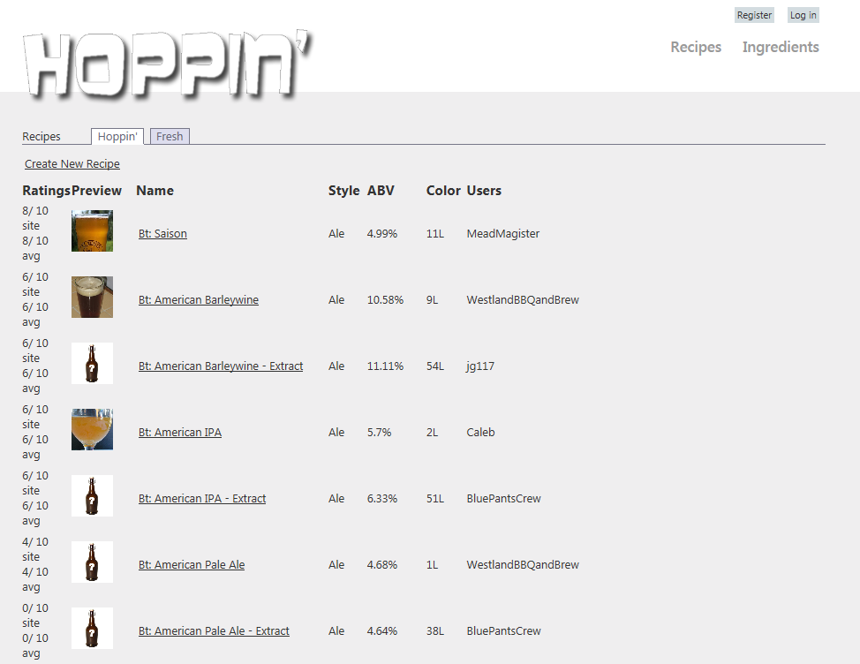
Also on this page are a number of links which navigate the user to other areas of the site. If a user clicks on one of the recipe names in the list, he is redirected to the recipe details page for that recipe. If the “Create New Recipe” hyperlink at the top left of the list beneath the “Hoppin” and “Fresh” tabs is clicked, the user is instead taken to the “create recipe” page. The “Register” and “Log in” buttons in the top-right corner take the user to the corresponding account management pages. “Ingredients” navigates the user to the ingredients section of the website, initially showing a list of hops. Clicking on the “Recipes” button returns the user to the current (main) page showing a list of recipes. It should be noted that the “Register”, “Log in”, “Recipes”, and “Ingredients” navigation aids, all appearing in the top right corner of the screen, are a part of the site-wide common layout and therefore always available for navigation while within the Hoppin’ Brew Social website.

User Login and Registration
Once an individual decides to contribute to Hoppin’ Brew Social they must first become a member. User Management for Hoppin’ Brew Social requires a user name for identification and password with confirmation. Once a user is registered they are automatically flagged as confirmed and are able to immediately log in to start contributing. Users may register by clicking the “Register” hyperlink located in the top-right corner of the web page, which navigates the user to the page shown below.

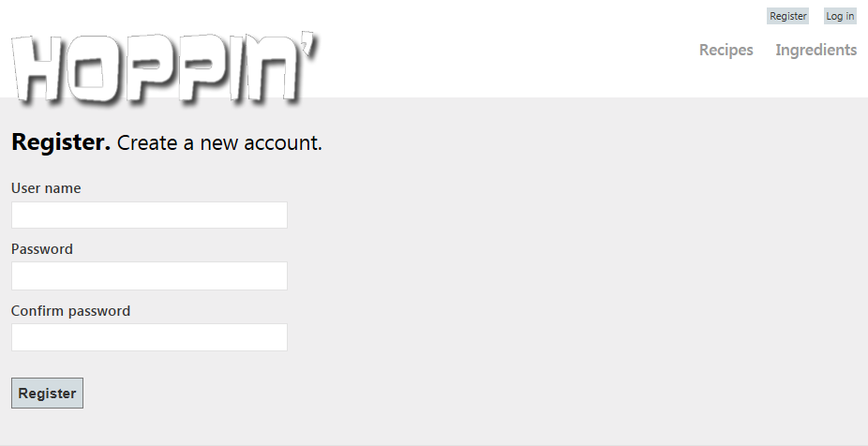
Members can log in using the User Login UI to submit their User Name and Password as shown in the figure below. The User Login UI is accessed through the “Log in” navigation aid; this page allows users to store a cookie with the site to remember the user’s login information after the “Remember me?” checkbox is selected.
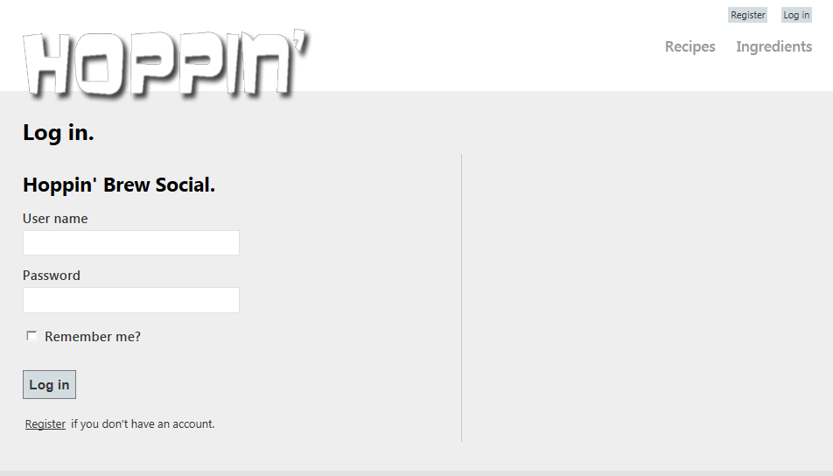
If incorrect login credentials are supplied, the UI displays a message to that effect:
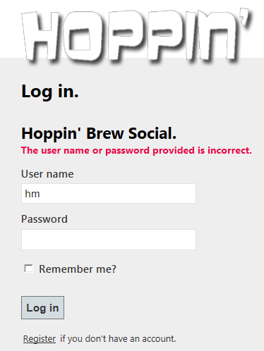
After logging in, the user’s name and “logged-in” status will replace the “Log in” navigational aid at the top of the screen.

Recipe Details Page
From the Recipes page showing the list of recipes in the site’s database, clicking on one of the recipe names brings the user to the Recipe Details page. This page displays the many details recorded in the database about the recipe, which represents everything an experienced brewer might need to recreate a particular brew. The figure below provides an example view of the upper portion of the Recipe Details page for the recipe named “Bt: American Barleywine” on the Hoppin’ Brew Social site.
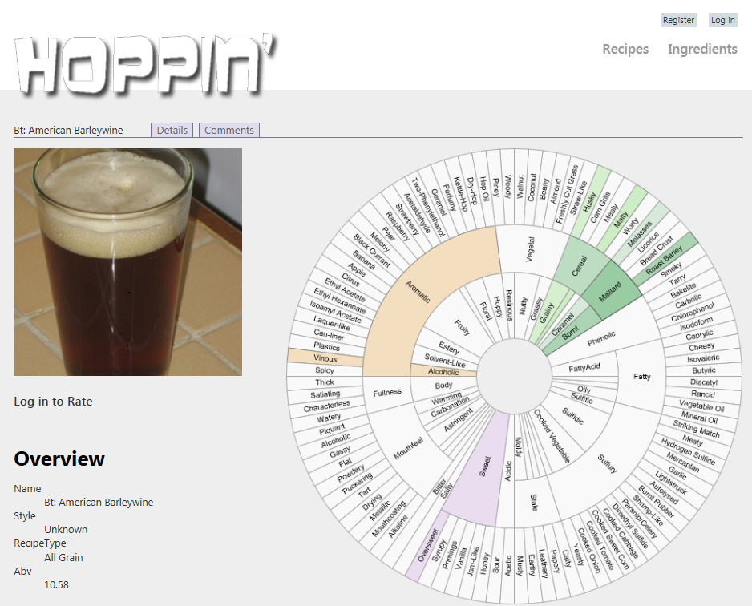
Additional information about the recipe may be seen by scrolling down the page; this includes information on the ingredients involved in the current recipe, its mash profile with mash steps, and community data such as the recipe’s site-wide approval rating. Also at the bottom of the page is an “Edit” hyperlink, which allows the user to edit the details of the recipe (provided he has the authorization to do so).
Users who are logged in may also submit an approval rating below the recipe image: 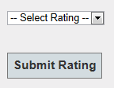
Edit Recipe Page
From the Recipe Details Page, if the user clicks the “Edit” hyperlink, he is taken to a page with the same details displayed, only now open to editing. It is from here that the user is able to make changes to the current recipe’s record in the database. The picture below shows the upper portion of this page, with fields available to edit the style and recipe type, as well as an option to upload an image to be displayed as representing the recipe graphically.
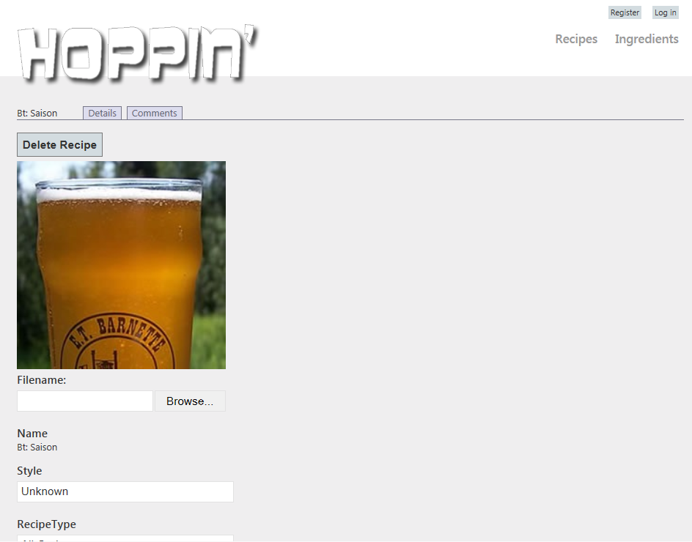
The “Delete” button resides in the top left corner of the page, above the recipe image; clicking this button will cause this recipe to be removed from the database. Further down the page are additional options to edit the details of the recipe’s mash, add or delete hops or fermentables, and edit the details of the mash steps.
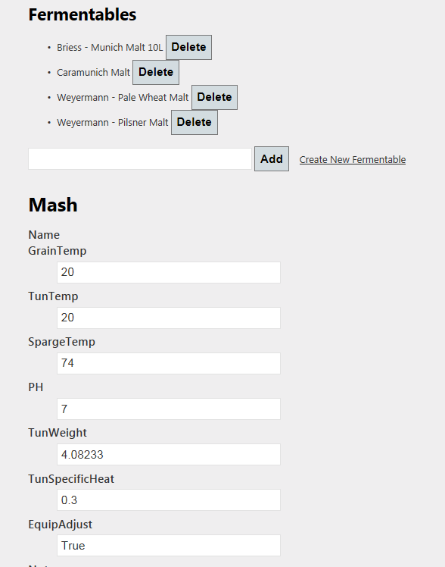
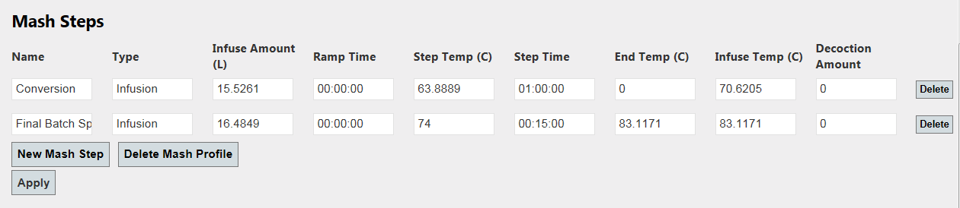
In addition to editing the details of the mash steps, the user also has the option of rearranging their order in the mash step sequence. This is accomplished by clicking on the area between editable text boxes for a given mash step’s row, and then dragging the row up or down to rearrange the step sequence order, as is depicted below.
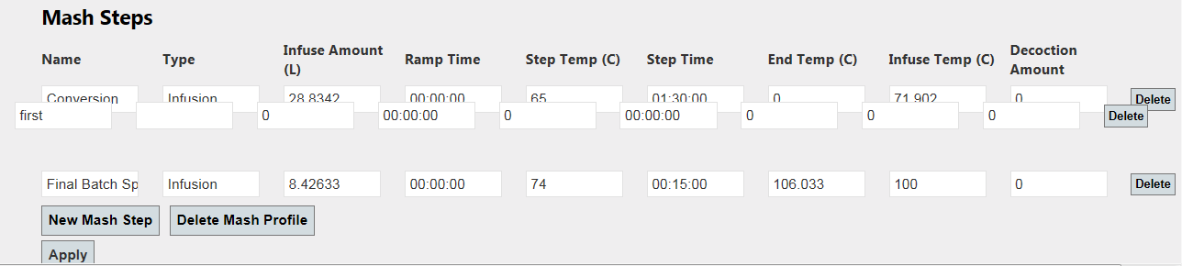
Once the user is done making changes, he can click the “Apply” button at the bottom of the screen to update the database record. Alternatively, the user may simply navigate away from this page to discard changes.

Create New Hop and Create New Fermentable Dialogs
If the user wishes to create a new hop or fermentable and add it to the database, this is also accomplished from the Edit Recipe page. By clicking the “Create New Hop” hyperlink in the Hops section of the page, a dialog appears allowing the user to input the details of a new hop record:
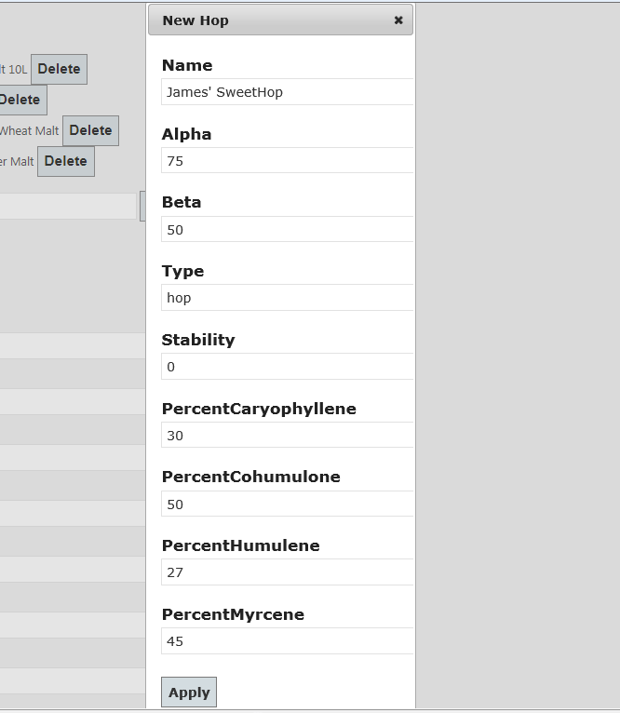
Clicking apply on this dialog adds the record to the database; clicking the “X” in the upper-right corner of the dialog navigates the user back to the Recipe Details Page. To create a new fermentable, the user similarly clicks on the “Create New Fermentable” hyperlink, upon which the following dialog appears:
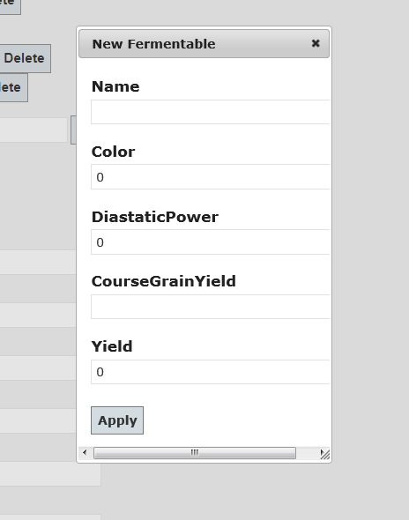
Again, clicking “Apply” adds the fermentable to the database, while “X” navigates the user away.

Recipe Comments Page
From the Recipe Details Page, the user may click on the “Comments” tab located near the upper-left corner of the screen. From there, the user is taken to a new page dedicated to user comments about the flavors of beer produced by following the recipe. Repeated here are some familiar features from the Recipe Details page to help maintain a sense of consistency between pages and also highlight data that might be the focus on the comments.
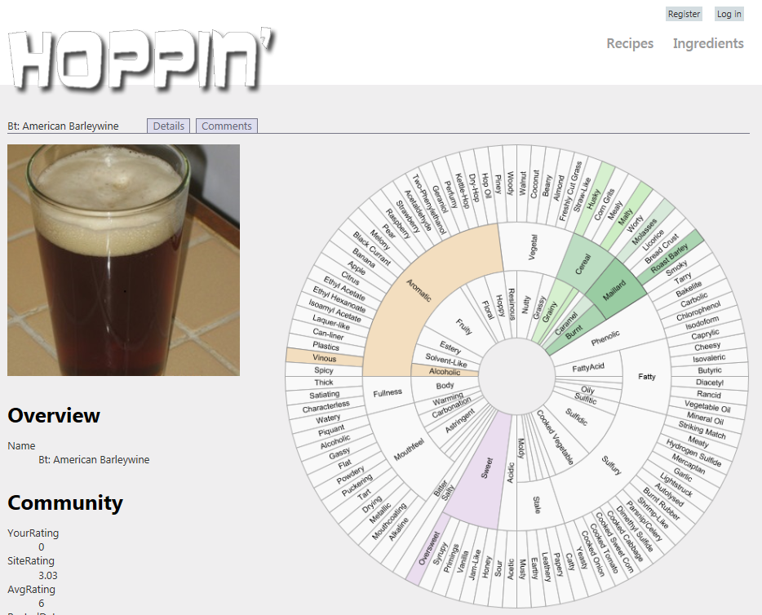
As the figure above shows, this upper portion of the page displays taste profile and approval rating information about the recipe, as well as the recipe’s representative image, or the default image if no user-uploaded image is available. Below this are the comments that users have posted for this particular recipe.
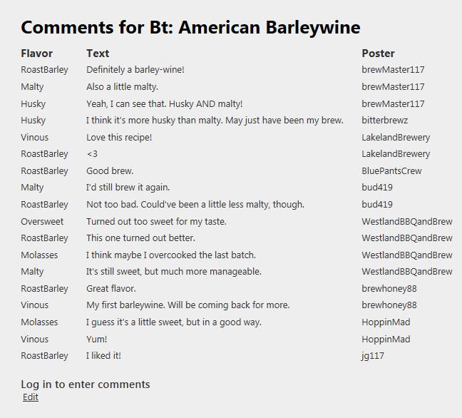
As indicated, if the user is logged in, they can enter comments of their own, which once submitted will store a Comment record in the database and then display their user name beside their comment in the updated list.
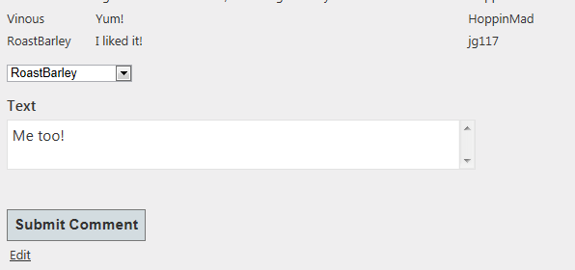
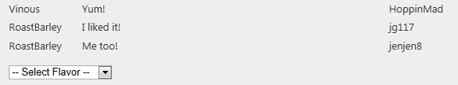

Ingredients Pages
In addition to viewing, editing, and commenting on recipes, users are also able to peruse the database’s list of ingredients available for inclusion in recipes on the site. By clicking on the “Ingredients” navigational aid located near the top-right corner of the screen, the user will be navigated to the first of these pages, a listing of all hops known to the database.
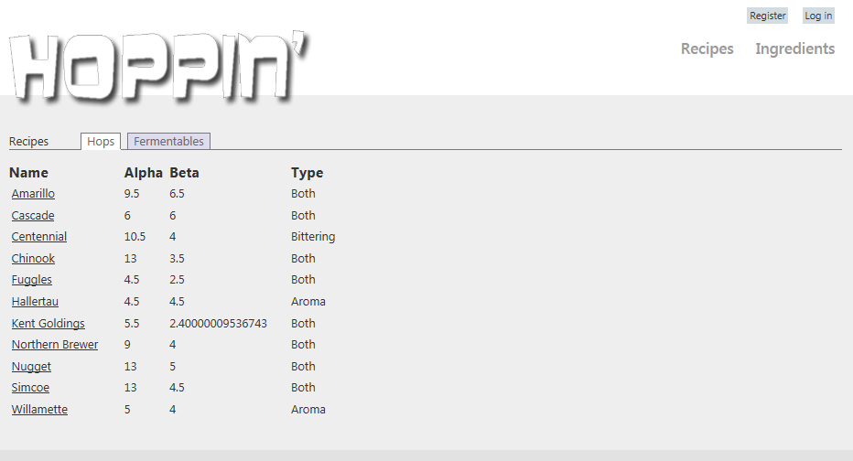
As with the Recipes List Page, clicking on the hyperlinked name of one of the hops takes the user to its Hop Details Page:
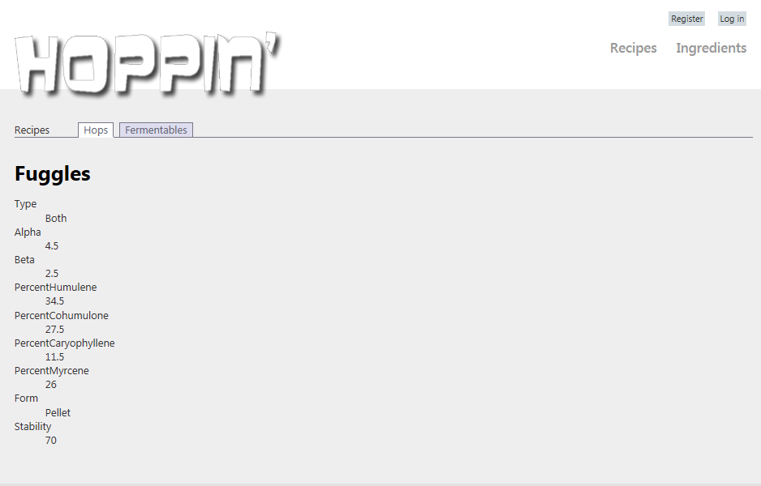

Clicking on the “Fermentables” Tab near the top-left corner of the screen navigates the user to the Fermentables List Page:
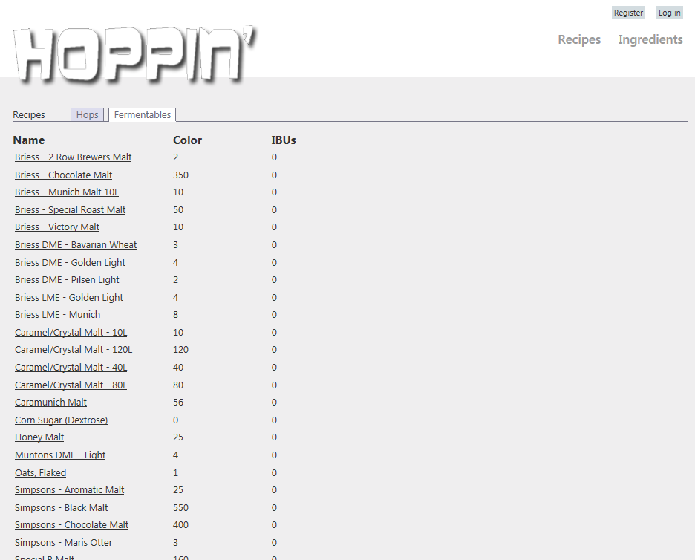
Again, clicking one of the hyperlinked names brings up the Fermentable Details Page:
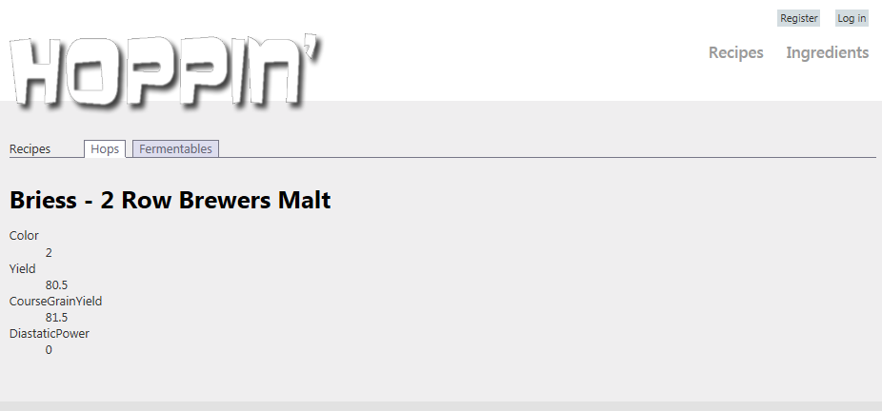
It should be noted here that these pages only list andn describe the characteristics of the ingredients which are currently available; new hops or fermentables must be added through the much more conveniently-situated “Add Hop” or “Add Fermentable” dialogs in the Edit Recipe Page, as previously described.

Create Recipe Page
Finally, the site would hardly be complete if users were unable to create and post their own new recipes for review by other brewing enthusiasts! To this purpose, the Create Recipe Page is available to users by navigating to the Recipes List Page (available from any other page by clicking on the “Recipes” navigational aid located near the top-right corner of the page; also the “starting” page all users navigate to first upon entering the site), followed by clicking on the “Create New Recipe” hyperlink located near the top-left corner of the page, above the recipes list but below the “Hoppin’” and “Fresh” tabs. From the Create Recipes Page, users are able to enter all of the data that is editable in the Edit Recipe Page, but are required to enter a unique recipe name as well. By clicking “Apply” at the bottom of the page, the new recipe is entered into the database, and will subsequently be available for viewing, editing, rating, and commenting by users on the site.
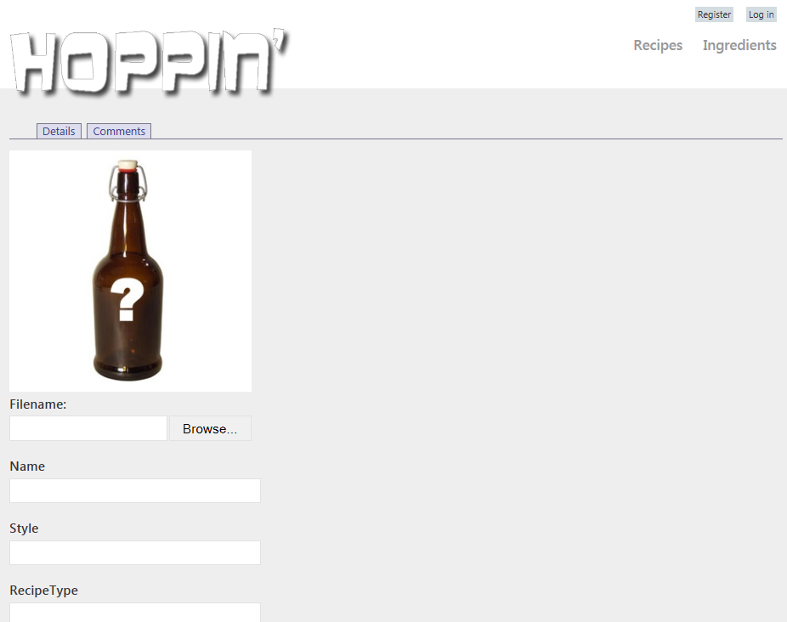
Special Note: Flavor Wheel
One of the most noticeable features available in the web UI is the flavor wheel. A “flavor wheel” is a graphical depiction of the terms most commonly used to describe the flavor of beer amongst brewing enthusiasts. Several variations on this concept have sprouted up in recent years; this application’s version is adapted from the freely-available and most popular version of this concept, which has come to gain widespread recognition and use in the online brewing enthusiast community.
A programmable version of the flavor wheel concept has been implemented in the UI of this application using Javascript and an HTML 5 canvas element for use in displaying the Hoppin’ Brew Social web site community’s collective description of the flavor of beer resulting from a particular recipe. When users leave comments on a recipe, they also supply one of a defined set of “flavor profiles,” each of which represents one of the descriptive terms located on the outer tier of the flavor wheel; the user’s flavor profile selection is then stored with the comment record in the database.
When a user loads a page containing a flavor wheel instance, the server queries the database to obtain a list of all comment records associated with the recipe which the flavor wheel instance will be used to describe. The records are then used to calculate percentage values for each flavor profile present in the comments; these percentages represent the proportion of comments which reference a given flavor profile to the overall comment count for this recipe. The percentages are then used as inputs to a basic Barycentric interpolation operation to obtain the interpolated color value between the flavor wheel’s default “off” color (a muted light gray), and the “on” color of the flavor profile’s designated section in the flavor wheel graphic.
As the inner tiers’ sections on the flavor wheel represent categories into which the outer tier’s flavor profiles may be logically grouped, they aggregate the percentages of their “child” flavor profile sections to determine their own interpolation inputs. Thus, the percentages of each of the tiers of the flavor wheel graphic sum to 100%, providing an intuitive graphical depiction of the “flavor” of brews produced by a given recipe, as reported by the community.
The figure below shows a screen capture of the flavor wheel for a “barleywine” recipe:
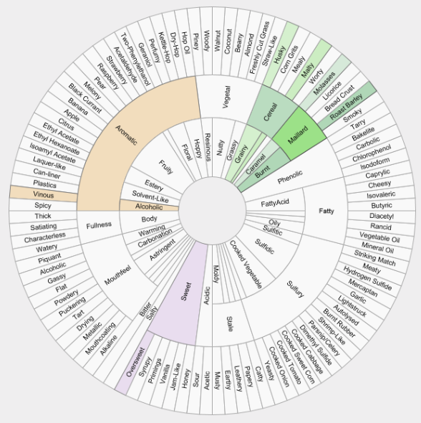
The flavor wheel is a visual component common to both the Recipe Details UI and the Recipe Comments UI.

Implementation Overview
The application is hosted locally on Internet Information Services which executes on the .Net framework through the Windows operating system. The application was developed using Visual Studio 2012 for Web using MVC with Razor in C#. The application communicates to a Microsoft Database File using Entity Framework Code First.
The architecture of Hoppin’ Brew Social is best described by the tiered design pattern common to web applications. The database is connected to the application through a SqlClient connection that only communicates with the models described using the Entity Framework attributes. The Entity Framework Model tier communicates with the BeerXML parser as a standalone application/script. The Entity Framework Models also communicate with the Views through the abstraction of View Models which serve only to separate the dependency on the Entity Framework from the Views. The Model-View-Controller architecture enabled development of the views to happen in parallel with the development of the Entity Framework Model tier. The Controllers work with the View Models to populate Views. This aspect of the application architecture is best described by the Model View Controller design pattern. The application architecture is depicted below:
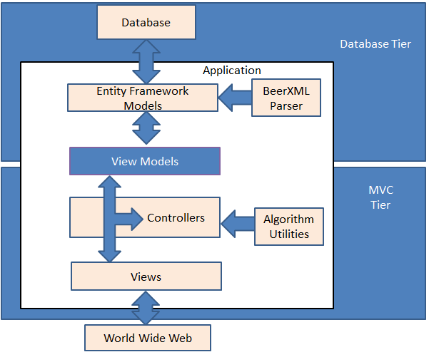

Here, Views are the first programmer-supplied artifact which the user directly encounters when making use of an MVC ASP-based server application. Views are composed of dynamically generated web content typically written in a mixture of C#, HTML, and AJAX. When the user transmits an HTTP request to the server, dedicated server code called Controllers intercept the request and determine how best to respond (generally with another view). Most View files tend to represent only part of an entire web document, and are combined by the appropriate Controller to best respond to the user's requests. Many partial Views also tend to be closely related to the Model classes for which they seek to display information.
Models in the MVC ASP framework are classes which serve as the mediators between database records and the server code. A seperate model class is created for each major relation in the database and given C# properties corresponding to the relation's attributes; these properties serve as "hooks" for the server code to be able to access record data as C# managed code primitives. Some tables in the database do not require a corresponding model class; these are mainly "join" tables, which serve to relate two or more "primary" entities in the database, and may not retain non-key attributes that the server code would otherwise be directly interested in.
Controllers in MVC serve the important role of mediating between the Views and models; they are the "active" code in the middle which handles user interaction events in the form of HTTP requests forwarded by the Views, performs queries on the database to retrieve raw information, performs additional computation on the data to ready it for display, and finally responds to the Views' HTTP requests with some result, typically a new View to display in the user's browser. Generally, complex data are first packaged up into container objects called ViewModels before they are sent to the View; in this way, the View may conveniently access all data needed to display the result to the user through a predefined interface provided by each ViewModel's class definition.
The bulk of the software implemented by the project team either falls into one of these four categories (Views, Models, Controllers, and ViewModels), or else exists as supplementary modules implementing special utility functions. As requested in the project description document, the various modules are listed below, organized by inclusion in each of these categories and accompanied by a brief description of their role in the context of the overall application.

Views:
_ChangePasswordPartial.cshtml - Partial view for presenting a web UI for the change password feature
_SetPasswordPartial.cshtml - Partial view for presenting a web UI for the set password feature
Login.cshtml - Partial view for presenting a web UI for the user login feature
Manage.cshtml - Partial view for presenting a web UI for the user account management feature
Register.cshtml - Partial view for presenting a web UI for the user account registration feature
FermentableViewModel.cshtml (display template) - Partial view for presenting a web UI for fermentable information display
HopViewModel.cshtml (display template) - Partial view for presenting a web UI for hop information display
FermentableViewModel.cshtml (editor template) - Partial view for presenting a web UI for allowing editing of fermentable information
HopViewModel.cshtml (editor template) - Partial view for presenting a web UI for allowing editing of hop information
_FermentableTable.cshtml - Partial view for presenting a web UI for the table of fermentables data in a recipe view
_HopTable.cshtml - Partial view for presenting a web UI for the table of hops data in a recipe view
Create.cshtml (Ingredients) - Partial view for presenting a web UI for creating new ingredients to be input into the database
List.cshtml (Ingredients) - Partial view for presenting a web UI for listing the ingredients already in the database
Show.cshtml (Ingredients) - Partial view for presenting a web UI for displaying information about a single ingredient
Update.cshtml (Ingredients) - Partial view for presenting a web UI for allowing a user to update the database record for a single ingredient
CommentsRecipeViewModel.cshtml (display template) - Partial view for presenting a web UI for recipe comments information display
DetailRecipeViewModel.cshtml (display template) - Partial view for presenting a web UI for display of detailed information about a single recipe
DetailRecipeViewModel.cshtml (editor template) - Partial view for presenting a web UI for allowing editing of detailed information about a single recipe
_RecipeEditorOnReady - AJAX code for updating the information displayed for a recipe upon receiving confirmation from the server that a recipe edit was completed successfully
Create.cshtml (Recipes) - Partial view for presenting a web UI for creating a new recipe
List.cshtml (Recipes) - Partial view for presenting a web UI for listing the recipes already in the database
Show.cshtml (Recipes) - Partial view for presenting a web UI for displaying information already in the database
Update.cshtml (Recipes) - Partial view for presenting a web UI for allowing a user to update the database record for a single recipe
_Layout.cshtml (Shared) - Provides the basic overall layout shared by all web UI views generated by the server application
_LoginPartial.cshtml (Shared) - Provides the additional shared layout for all account management web UI views generated by the server application
Error.cshtml (Shared) - Partial view for displaying an error message if an error was encountered while entering user login information
_ViewStart - Anchor view used to indicate which other partial view files to look for when generating a complete web page document for return to the client

ViewModels:
FermentableListItemViewModel - Data container class used to pass data needed by the view for displaying information about a fermentable list item
FermentableViewModel - Data container class used to pass data needed by the view for displaying information about a fermentable
HopListItemViewModel - Data container class used to pass data needed by the view for displaying information about a hop list item
HopViewModel - Data container class used to pass data needed by the view for displaying information about a hop
IngredientListViewModel - Data container class used to pass data needed by the view for displaying information about an ingredient list
IngredientViewModel - Data container class used to pass data needed by the view for displaying information about a single ingredient
CommentsRecipeViewModel - Data container class used to pass data needed by the view for displaying information about the comments for a given recipe
CommentViewModel - Data container class used to pass data needed by the view for displaying information about a single comment
DetailRecipeViewModel - Data container class used to pass data needed by the view for displaying information about a detailed view of a single recipe
MashProfileViewModel - Data container class used to pass data needed by the view for displaying information about a sing - Data container class used to pass data needed by the view for displaying information about a single mash profile
RecipeListItemViewModel - Data container class used to pass data needed by the view for displaying information about a recipe list item
RecipeListViewModel - Data container class used to pass data needed by the view for displaying information about a list of recipes
RecipeViewModel - Data container class used to pass data needed by the view for displaying information about a single recipe (not detailed)

Controllers:
Account Controller - Handles user interaction, database access, and view instantiation for events from user account views
BeerImageController - Handles user retrieval of sample beer image for views
IngredientsController - Handles user interaction, database access, and view instantiation for events from recipe ingredients views
RecipesController - Handles user interaction, database access, and view instantiation for events from recipe and comments views

Models:
UserProfile - Controls access to the underlying UserProfile database table
LocalPasswordModel - Defines locally instantiated model password type associated with login view
LoginModel - Defines locally instantiated model for login view
RegisterModel - Defines locally instantiated model for user registration view
FlavorProfile - Controls access to the underlying FlavorProfile database table
Comment - Controls access to the underlying Comment database table
FermentableType - Controls access to the underlying FermentableType database table
Fermentable - Controls access to the underlying Fermentable database table
HopForm - Controls access to the underlying HopForm database table
HopType - Controls access to the underlying HopType database table
HopUse - Controls access to the underlying HopUse database table
Hop - Controls access to the underlying Hop database table
HopSubstitute - Controls access to the underlying HopSubstitute database table
MashProfile - Controls access to the underlying MashProfile database table
MashStepType - Controls access to the underlying MashStepType database table
MashStep - Controls access to the underlying MashStep database table
Rating - Controls access to the underlying Rating database table
RecipeFermentable - Controls access to the underlying RecipeFermentables database table
RecipeHop - Controls access to the underlying RecipeHops database table
RecipieType - Controls access to the underlying RecipieType database table
Recipe - Controls access to the underlying Recipe database table
RecipeYeast - Controls access to the underlying RecipeYeasts database table
StyleType - Controls access to the underlying StyleType database table
Style - Controls access to the underlying Style database table
YeastType - Controls access to the underlying YeastType database table
YeastForm - Controls access to the underlying YeastForm database table
YeastFlocculations - Controls access to the underlying YeastFlocculations database table
Yeast - Controls access to the underlying Yeast database table

Utilities:
BrewCharacteristicAlgs - Provides static utility methods used for auto-calculation certain derived brew result characteristics
StatisticsUtils - Provides static utility methods used to determine the (Bayesian) "site" average rating and local average rating for recipes

Misc:
BrewXMLParser - Provides functionality for parsing data files using the "BeerXML" standard for purposes of populating some parts of the application database with sample beer recipes and ingredients information
PagedList<T> - Template class for displaying containing "pages" of generic items; used to organize "pages" of recipe list items for sequential display by the views.

Meeting Minutes
Detailed notes were captured for each official team meeting described in the table below. Beyond the meetings, several dozen emails were sent and many lengthy Skype conversations concerning project development took pace. All team members worked hard to meet the project goals, and overall the team believes they were successful in their efforts.
Date/Time | Location | Attendees | Duration [Minutes] | Topic / Discussion Details
2/4/13 6:55 | UAH | All | 20 | Database environment options. SQLite, Compact, and Microsoft Database File were suggested and we chose Microsoft Database File.  Programming environment options. Team narrowed the options to C# ASP.net classic and MVC. James took the action item of investigating MVC.  Source Control options. Team decided to use GitHub so each member had to create an account on GitHub.  Michael suggested BeerXML as a source for populating the database with realistic information so Caleb as the database lead took the action item of investigating that.
2/11/13 6:55 | UAH | All | 20 | Michael suggested that Entity Framework be used to generate the database using Code First. Caleb took the action item to investigate Code First.  Discussed how to handle enumerations in the database. Michael suggested that Entity Framework might support it and Caleb took the action item to investigate.  Michael took the action item to create an initial project setup for the git repository.  Goal for next meeting is for all team members to draft potential view ideas. And to follow the MVC tutorials online.
2/18/13 6:55 | UAH | All | 20 | James presented the design of a view component called “Beer Flavor Wheel” which allowed users to have a graphical representation for the flavor of a beer.  Michael presented designs for the sortable tabbed home page and recipe edit pages.  Caleb came up with the name “Hoppin’ Brew Social” and suggested that the columns be sorted by most “Hoppin’”.
3/13/13 6:55 | UAH | All | 10 | Caleb decided that he would use Entity Framework for connecting the database to the application code.  Michael suggested that he could start implementation of the views by separating the view model from the database model.  James continued implementation of the Flavor Wheel.  Caleb took the action item to present database schema draft.
4/1/13 6:55 | UAH | All | 5 | Caleb presented the schema draft and took the action item to implement the schema and parse the beerXML into it.  Michael took the action item of sending Caleb beerXML information.
4/3/13 6:55 | UAH | All | 15 | James took the responsibility of formatting and managing the report over all.  Caleb took the action item to write the database portion of the report. Caleb also agreed to create a user management and login page for the application.  Michael continued work on the application views.
4/8/13 6:55 | UAH | All | 15 | Team each volunteered responsibility for sections of the report.  Caleb presented an updated schema of the database.  James suggested that a comment table be added and that Amount should be move to the join tables.  Michael suggested that the isMashed, isSecondary, and HopUse be moved to the join tables.  James took the action item of creating a the ER diagram.

Example brew recipe data obtained from the “BeerXML” standardized recipe description document accompanying the open-source brew recipe editor program “Brewtarget”, version 2.0.1, available at (www.brewtarget.org)
A static image version is freely available for download and distribution at (www.beerflavorwheel.com)

